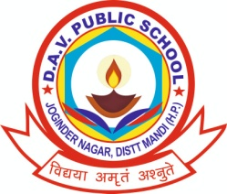
DAV PUBLIC SCHOOL (Garoru)Tehsil, Joginder Nagar, Distt. Mandi (HP)
Contact No: 9816057965, Pin Code: 175015, 01908-222188

Dear Candidates, You are hereby informed that the date for the written examination will be 6th of March, 22 and the timing is of 2hours.
i.e.:- 9:00 am to 11:00 am (PRTs)
12:00 pm to 2:00 pm (TGTs)
NOTE: - The candidates will report 15 minutes earlier from the scheduled time.

REGARDS
SANJAY THAKUR
(PRINCIPAL, DAVPS (J/NAGAR))

