GENERAL AFFILIATION AS PER DETAILS GIVEN BELOW:
AFFILIATION NO. | 531758
AFFILIATED FOR | SECONDRY SCHOOL EXAMINATION CLASS 1 TO 10
CAREGORY | FRESH AFFILIATION
PERIOD OF GENERAL AFFILIATION | 01.04.2020 TO 31.03.2023
YEAR AND MONTH FROM WHICH ADMISSION CAN BE TAKEN IN CLASS- IX | 1 APRIL ,2020
YEAR AND MONTH IN WHICH FIRST BATCH OF CLASS-X WILL APPEAR IN BOARD EXAMINATIONS. | MARCH,2022

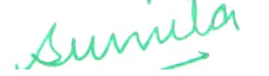
Headmistress
DAV Police Public School
Police Lines Karnal

