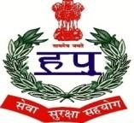

D.A.V POLICE PUBLIC SCHOOL
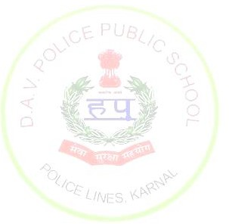
POLICE LINES, KARNAL – 132001 (HARYANA)
Affiliated to CBSE.New Delhi Vide No.531758
_________________________________________________________________________________________________ STUDENT’S STRENGTH
SESSION 2023-24

tt
CLASS | TOTAL NUMBER OF SECTIONS | TOTAL PER CLASS INTAKE | TOTAL NO OF STUDENTS
1ST | 2 | 45 | 85
2ND | 2 | 45 | 83
3RD | 3 | 45 | 105
4TH | 3 | 45 | 100
5TH | 3 | 45 | 102
6TH | 3 | 45 | 105
7TH | 2 | 45 | 87
8TH | 3 | 45 | 85
9TH | 2 | 45 | 88
10TH | 3 | 45 | 88
11TH | 3 | 45 | 74
12TH | 3 | 45 | 56

