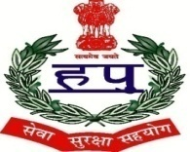
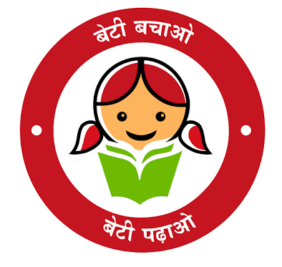

D .A .V POLICE PUBLIC SCHOOL
POLICE LINES, KARNAL – 132001 (HARYANA)
AFFILIATED TO CBSE NEW DELHI (CODE-531758)
LIST OF TEXTBOOKS
SESSION(2020-21)

Class L.K.G
Sr.No. | Book Name
1. | Fun With English
2. | Integrated Activity Book
3. | Fun with Math
4. | Rhythemic Rhyme
5. | Fun with color-A
6. | Akshar Parichay
7. | Drawing File
8. | Activity kit

Class U.K.G
Sr.No. | Book Name
1. | My English Book
2. | Integrated Activity Book
3. | Kindergarden Math
4. | Bal Madhuri
5. | Shabad Abhyas
6. | Fun With Colour – b
7. | Drawing File
8. | Activity kit

Class I
Sr.No. | Book Name
1. | My English Reader
2. | English Practice Book
3. | My living words
4. | Prime math
5. | Bhasha madhuri
6. | Bhasha abhyas
7. | Step- by- step 1
8. | Dharma shiksha
9. | Tech Era
10. | Activity kit
11. | Drawing file

Class II
Sr.No. | Book Name
1. | My English Reader
2. | English Practice Book
3. | My living words
4. | Prime math
5. | Bhasha madhuri
6. | Bhasha abhyas
7. | Step- by- step 1
8. | Dharma shiksha
9. | Tech Era
10. | Activity kit
11. | Drawing file

Class III
Sr.No. | Book Name
1. | My English Reader
2. | English Practice Book
3. | My living words
4. | Prime math
5. | Bhasha madhuri
6. | Bhasha Abhyas
7. | Kid Wiz(G.K)
8. | Dharma shiksha
9. | Hands On
10. | We and Our World
11 | Step- by- Step 3

Class IV
Sr.No. | Book Name
1. | My English Reader
2. | English Practice Book
3. | My living words
4. | Prime math
5. | Bhasha madhuri
6. | Bhasha Abhyas
7. | Kid Wiz(G.K)
8. | Dharma shiksha
9. | Hands On
10. | We and Our World
11 | Step- by- Step 4

Class V
Sr.No. | Book Name
1. | My English Reader
2. | English Practice Book
3. | My living words
4. | Prime math
5. | Bhasha madhuri
6. | Bhasha Abhyas
7. | Kid Wiz(G.K)
8. | Dharma shiksha
9. | Hands On
10. | We and Our World
11. | Step- by- Step 5
12. | Surbhi(Sanskrit)

Class VI
Sr.No. | Book Name
1. | My English Reader
2. | English Practice Book
3. | My living words
4. | Secondary Math
5. | Gyan Sagar
6. | Abhayas Sagar
7. | Kid Wiz(G.K)
8. | Dharma shiksha
9. | Hands On
10. | We and Our World
11. | Step- by- Step 6
12. | Surbhi(Sanskrit)
13. | English Literature

