Index
Pages:
Sl No Description
- Title of Project
- Certificate to authenticated work
- Software and Hardware Requirements
- Your Project Contents( Minimum 15 pages)

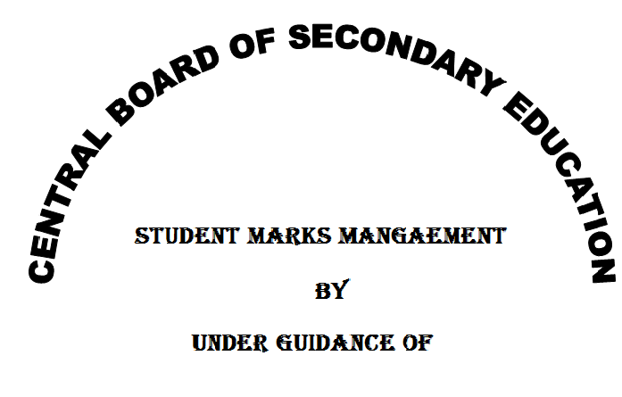
…………………..

Name: ……………………
CLASS: ……
SEC:-
Roll:- Teacher’s Sign and Remarks
CERTIFICATE OF AUTHENTICATED WORK

This is to certify that that the project report entitled “……………………………..”
submitted to “Central Board Of Secondary Education”.The matter embodied in this project is authentic and is genuine work done by the student.

……………………. ………………………….
Sign of the student Sign of the counsellor
Address:………………… Address:…………………
………………………….. ………………………….
…………………………… ………………………….

Software and hardware requirements

Hardware requirements:-
RAM:- ……………….
Hard disk:-
Processor:-
Software requirements:-
- Tick the Application Software
- Ms Word
- Ms Excel
- Ms PowerPoint
- Ms Access
- Tick the Operating System
- Windows XP
- Windows 7
- Windows 8.1

