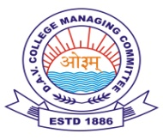
DAV HZL SR. SEC. SCHOOL ZAWAR MINES
CLASS XI (ARTS)
DIWALI BREAK ASSIGNMENT (2022-23)

ENGLISH
- Write your own experiences about the following topics (word limit 500 to 600 words)
A.What is your plans to celebrate Diwali?
B. How did you celebrate Diwali?
(Note: - Write B topic after Diwali)
POLITICAL SCIENCE
- Complete given project work in practical file.
- On the Political map of India locate and label the states having a bicameral legislature.
SOCIOLOGY
- Complete given project work in practical file.
PHYSICAL EDUCATION
- Complete given project work-1 in practical file ( 400 mt.track and field events)
COMPUTER SCIENCE
- Complete given practical work.
- Write a python program to create calculator.
PAINTING
- Make a picture composition of Diwali celebration on half Chart Paper.

