DAV HZL SR. SEC. SCHOOL, DARIBA
TENTATIVE CO-CURRICULAR ACTIVITIES 2022-23
Date | Classes | Events
15/04/23 | III TO V  VI TO VIII  IX TO XII | "Beaded Beauty: Exploring the Art of Beadwork"  Quelling Art: Exploring Paper Filigree Techniques"  "Preserving Our Planet: An Environmental Power Point Presentation"
29/04/23 | III TO V  VI TO IX | "Mastering English Eloquence"  "Quick Talk: English Extempore"
10/05/23 |  | Annual function
01/07/23 | III TO VII | Arya samaj related movie
07/07/23 | III TO VIII  IX TO XII | Trees are poems that the earth writes upon the sky.”Plantation drive  Inter-house documentary on exploring Dariba
15/07/23 | III TO V  VI TO IX | "Script Scribbles: The English Handwriting Challenge"  Hindi extempore
18/07/23 | III TO XII | "Crowning Moments: The Investiture Ceremony"
28/07/23 | III TO V  VI TO X | "Articulate Ambitions: The English Speech Contest" Inter-house  "Speak Up: The Power of Words"- English Debate Competition (Inter house English debate)
19/08/23 | III TO X | "Exploring Society: A Social Science Quiz"
02/09/23 | III TO V  VI TO X | Inter house Hindi speech  Inter house Hindi debate
07/10/23 | III TO V  VI TO VII  VIII  IX TO XII | Cartooning or Poster making Awareness towards Cleanliness  Rally  Community services  Inter house video making
21/10/23 | III TO V  VI TO VIII | Inter-house Singing bhajan With musical instrument  Shlok Manthan: Delving into the Depths of Sanskrit"
04/11/23 | III TO XII | "Sci-Quest: A Journey through the Wonders of Science"
18/11/23 |  | "Fun Fair Showcase" Exhibition and Fete
02/12/23 | III TO V  VI TO IX | "The Art of Expression: An English Monologue Competition"  "Act Out: An English Role play and Skit Competition"
23/12/23 | III TO XII | "Maths Mania Quiz"
06/01/24 | III TO V | "Mold Your Creativity" Clay Modelling
20/01/24 | III TO V | "Proudly Poetic: Celebrating Patriotism"  English Poem Recitation
27/01/24 | III TO V | "Folded Wonders- Origami Scenery Contest"
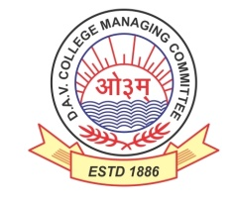
DAV HZL Sr. Sec. School dariba
rajsamand (raj.)

DAV HZL Sr. Sec. School dariba, rajsamand(raj.)

Split-up Syllabus
Class- III

Split-up Syllabus & Activities
for the session
2022-23
Class-X

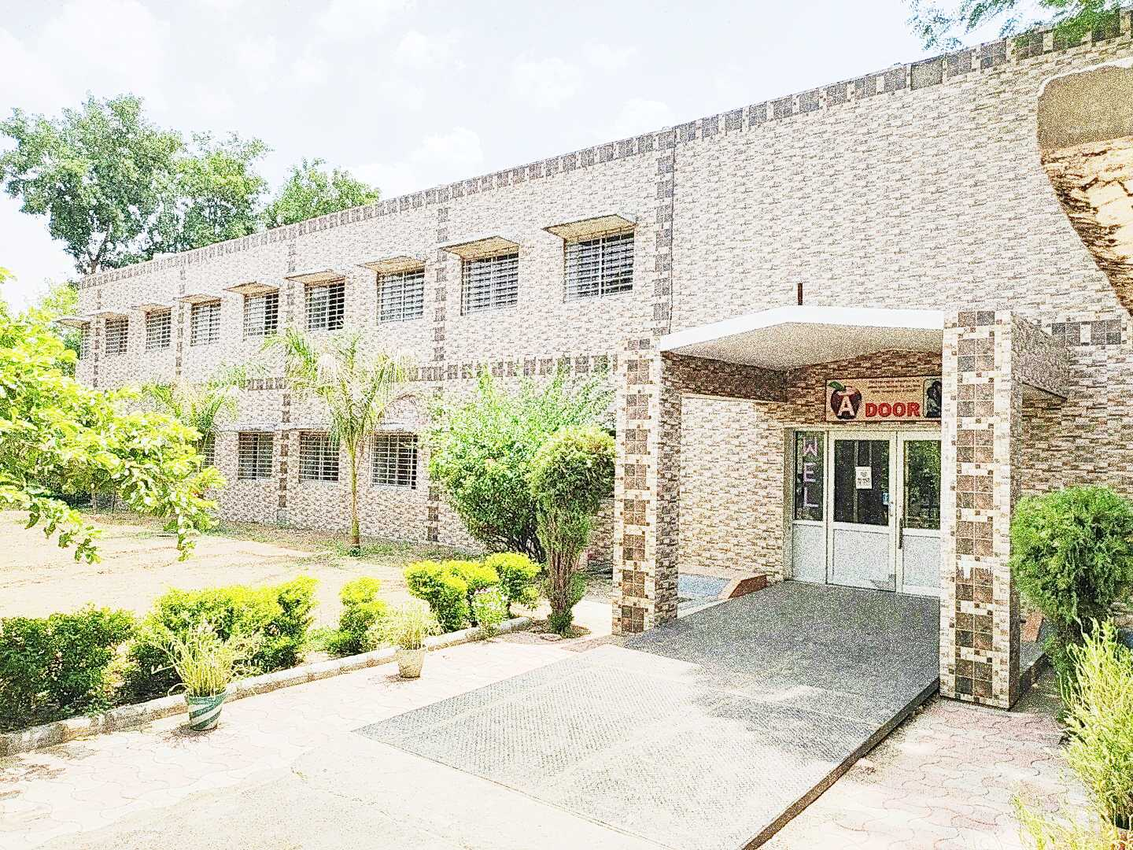

Address : Rajpura-Dariba, Distt. – Rajsamand (Raj.) 313211
Contact : (02952)265130 Email : davhzl_dariba@yahoo.com Website : ttp://www.davhzldariba.in
Subject |  | PT- I | PT- II
English |  | A Letter to God, Dust of Snow, Tenses | Nelson Mandela, A Triumph of Surgery, A Tiger in the Zoo, How to Tell Wild Animals, Modals, Letter- Writing
Hindi |  | f{kfrt dkO; [kaM ikB & 1 lwjnkl ¼in½  f{kfrt x| [kaM ikB & 10 Lo;a izdk'k ¼usrkth dk p'ek½  ys[ku] vifBr x|ka'k | f{kfrt dkO; [kaM ikB & 2 rqylhnkl & jke y{e.k & ij'kqjke laokn  x| [kaM ikB & 11 jkeo`{k csuhiqj cky xksfcu Hkxr  Ñfrdk ikB & 1 ekrk dk vkapy  O;kdj.k & vyadkj] foKkiu ys[ku
Maths |  | Chapter – 1 & 2 | Chapter – 3, 4
Sci | Che. | Chapter – 1 | Chapter – 2
 | Phy. | Chapter – 10 | Chapter – 11 (Till taught)
 | Bio. | Chapter – 5 | Chapter – 6
S.St. | Eco. | - | Chapter – 1
 | His. | Chapter – 1 | -
 | Geo. | Chapter – 1 | -
 | Civics | - | Chapter – 1
ICT |  | Unit – 3 | Unit – 6

Subject |  | Mid Term
English |  | Prose- A letter to God, Nelson Mandela - Long Walk to Freedom, Two Stories About Flying From the Diary of Anne Frank, Glimpses of India  A Triumph of Surgery, The Thief's Story, The Midnight Visitor, A Question of Trust, Footprints Without Feet  Poem- Dust of Snow, Fire and Ice, A Tiger in the Zoo, How to Tell Wild Animals, The Ball Poem,  Formal Letter, Grammar- Tenses, Modals, Subject – verb concord
Hindi |  | dkO; [kaM & ikB & 1] 2] 3] 4 x| [kaM & ikB & 10] 11] 12] 13  Ñfrdk ikB & 1 ekrk dk vkapy  vifBr x|ka'k] vifBr dkO;ka'k] O;kdj.k okP; in ifjp;] vyadkj] jpuk ds vk/kkj ij okD; Hksn] in ifjp;] vuqPNsn ys[ku] i= ys[ku] bZesy ys[ku] foKkiu ys[ku
Maths |  | Chapter – 1, 2, 3, 4, 5, 7, 10, 13, 14
Sci. | Che. | Chapter – 1, 2
 | Phy. | Chapter – 10, 11
 | Bio. | Chapter – 5, 6, & 7
S. St. | Eco. | Chapter – 1, 2
 | His. | Chapter – 1, 2 & 3
 | Geo. | Chapter – 1, 2
 | Civics | Chapter – 1, 2
ICT |  | Unit – 1, 2, 3, 6, 7

Subject |  | PT – III
English |  | Mijbil the Otter, Madam Rides the Bus, The Ball Poem  Reported speech, Aanalytical Paragraph
Hindi |  | dkO; [kaM & ikB & 5 lw;Zdkar f=ikBh ^fujkyk* & mRlkg] vV ugha jgh gS  x| [kaM & ikB & 14 eUuw HkaMkjh & ,d dgkuh ;g Hkh  Ñfrdk & ikB & 2 lkuk lkuk gkFk tksM+h] i= ys[ku
Maths |  | Chapter – 8 & 9
Sci. | Che. | Ch. – 3
 | Phy. | Ch. – 12
 | Bio. | Chapter – 9
S. St. | Geo. | Chapter – 3
 | Civics | Chapter – 3
ICT. |  | Unit – 4 & 5

Subject |  | Final Term
English |  | Complete Course (As per updated syllabus)
Hindi |  | lEiw.kZ ikB~;Øe O;kdj.k Hkkx $ ys[ku jpuk
Maths |  | Chapter – 1 to 14
Sci. | Che. | Complete Course (As per updated syllabus)
 | Phy. | Complete Course (As per updated syllabus)
 | Bio. | Complete Course (As per updated syllabus)
S. St. |  | Complete Course (As per updated syllabus)
ICT. |  | Complete Course (As per updated syllabus)

Exam | TENTATIVE DATES OF EXAM
UT- I | First week of May , 2023
UT- II | First week of August, 2023
MID – TERM | Mid September , 2023
UT – III | Last Week of November, 2023
Pre Board – I | 2nd- 3rd week of December
Pre Board – II | Third Week of January, 2024
Final Term | Third Week of February, 2024

