DAV HZL SR. SEC. SCHOOL, DARIBA
TENTATIVE CO-CURRICULAR ACTIVITIES 2022-23
Date | Classes | Events
15/04/23 | III TO V  VI TO VIII  IX TO XII | "Beaded Beauty: Exploring the Art of Beadwork"  Quelling Art: Exploring Paper Filigree Techniques"  "Preserving Our Planet: An Environmental Power Point Presentation"
29/04/23 | III TO V  VI TO IX | "Mastering English Eloquence"  "Quick Talk: English Extempore"
10/05/23 |  | Annual function
01/07/23 | III TO VII | Arya samaj related movie
07/07/23 | III TO VIII  IX TO XII | Trees are poems that the earth writes upon the sky.”Plantation drive  Inter-house documentary on exploring Dariba
15/07/23 | III TO V  VI TO IX | "Script Scribbles: The English Handwriting Challenge"  Hindi extempore
18/07/23 | III TO XII | "Crowning Moments: The Investiture Ceremony"
28/07/23 | III TO V  VI TO X | "Articulate Ambitions: The English Speech Contest" Inter-house  "Speak Up: The Power of Words"- English Debate Competition (Inter house English debate)
19/08/23 | III TO X | "Exploring Society: A Social Science Quiz"
02/09/23 | III TO V  VI TO X | Inter house Hindi speech  Inter house Hindi debate
07/10/23 | III TO V  VI TO VII  VIII  IX TO XII | Cartooning or Poster making Awareness towards Cleanliness  Rally  Community services  Inter house video making
21/10/23 | III TO V  VI TO VIII | Inter-house Singing bhajan With musical instrument  Shlok Manthan: Delving into the Depths of Sanskrit"
04/11/23 | III TO XII | "Sci-Quest: A Journey through the Wonders of Science"
18/11/23 |  | "Fun Fair Showcase" Exhibition and Fete
02/12/23 | III TO V  VI TO IX | "The Art of Expression: An English Monologue Competition"  "Act Out: An English Role play and Skit Competition"
23/12/23 | III TO XII | "Maths Mania Quiz"
06/01/24 | III TO V | "Mold Your Creativity" Clay Modelling
20/01/24 | III TO V | "Proudly Poetic: Celebrating Patriotism"  English Poem Recitation
27/01/24 | III TO V | "Folded Wonders- Origami Scenery Contest"
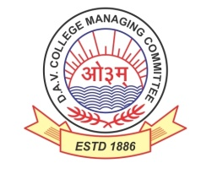
DAV HZL Sr. Sec. School dariba
rajsamand (raj.)

DAV HZL Sr. Sec. School dariba, rajsamand(raj.)

Split-up Syllabus
Class- III

Split-up Syllabus & Activities
for the session
2023-24
Class-VIII

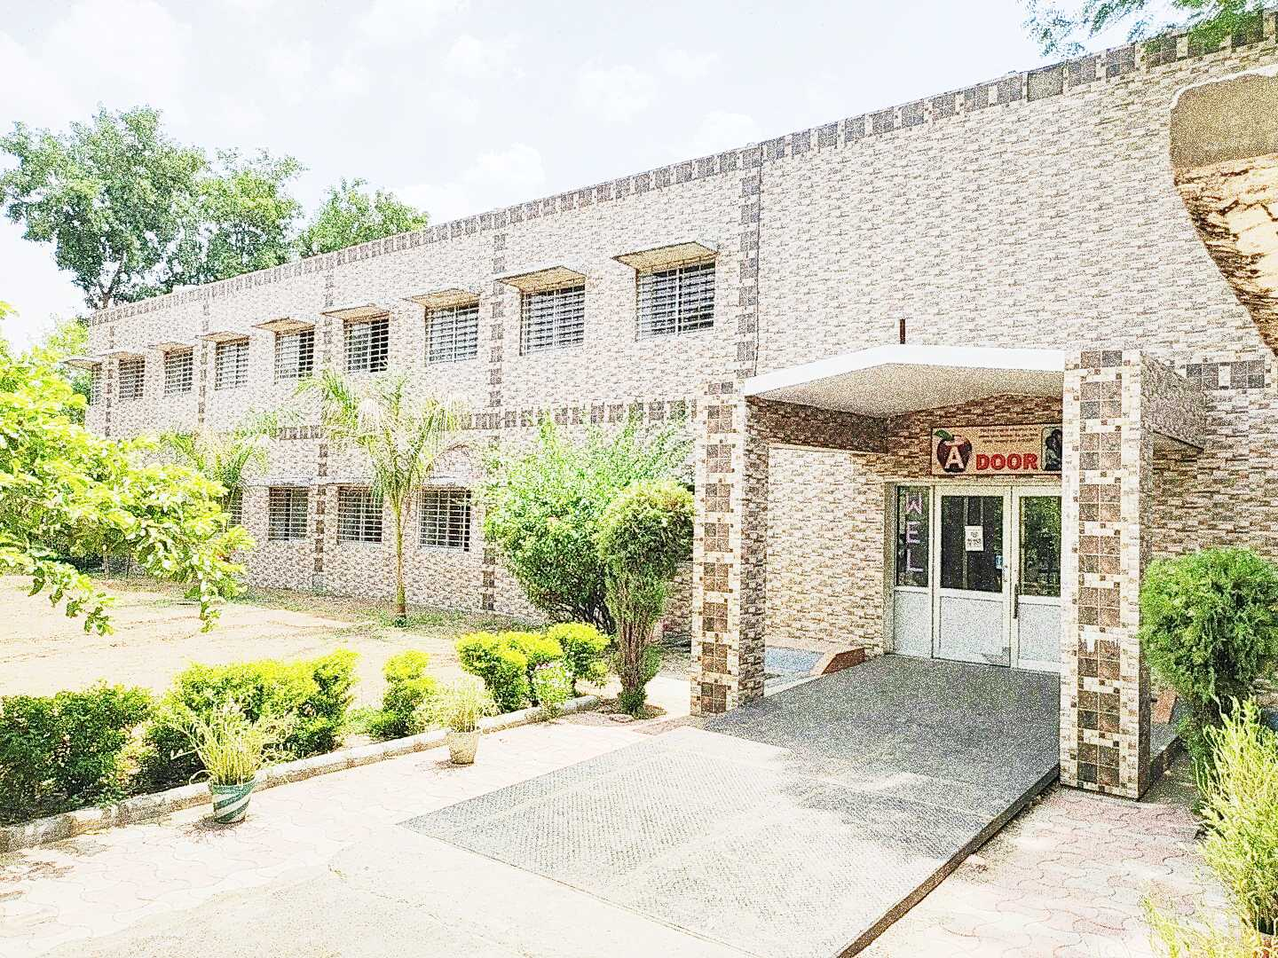

Address : Rajpura-Dariba, Distt. – Rajsamand (Raj.) 313211
Contact : (02952)265130 Email : davhzl_dariba@yahoo.com Website : www.davhzldariba.com
Subject | PT- I | PT- II
English | Eng. Lit. – Lesson – 1  Practice Book – Lesson – 1 | Eng. Lit. – Lesson – 3  Practice Book – Lesson – 2
Hindi | Kku lkxj % ikB & 1  vH;kl lkxj % ikB & 1 | Kku lkxj % ikB & 2  vH;kl lkxj % ikB & 2
Maths | Chapter – 1, 2 | Chapter – 3, 4
Science | Lesson – 1 | Lesson – 2, 3
S.St. | Lesson – 1 & 8 | Lesson – 9 & 16
laLÑr | ikB & 1] 2 | ikB & 3] 4] milxZ&vO;;
Computer Sc. | Chapter – 1 | Chapter – 2
Moral Edu. | ikB & 1 | ikB & 2
G. K. |  | Unit – 5

Subject | Mid Term
English | Eng. Lit. – Lesson – 1 to 6 Practice Book – Lesson – 1 to 5  Reader Book – Unit 1 to 3
Hindi | Kku lkxj % ikB & 1] 2] 3] 4] 5] 6] 7] 8] 9] 10  vH;kl lkxj % ikB & 1] 2] 3] 4] 5] 6] 7] 8] 9] 10
Maths | Ch. – 1, 2, 3, 4, 5, 10, 11, 12
Science | Lesson – 1 to 10
S. St. | Lesson – 1, 2, 3, 8, 9, 10, 11, 16, 17 & 18
laLÑr | ikB & 1 ls 6] rFkk O;kdj.e~ milxZ] vO;;] izR;;%] lfU/k] 'kCn:i] /kkrq:i] la[;k 1 & 50] miin foHkfDr] ¼izFkek ls prqFkhZ½] vifBr x|ka'k] fp=o.kZue~] vuqPNsn ys[kue~] okD;kuqokn]
Computer Sc. | Chapter – 1 to 4
Moral Edu. | ikB & 1 ls 9
G. K. | Unit – 4 to 6
Drawing | Page No. 1 to 20

Subject | PT- III
English | Eng. Lit. – Lesson –4 Practice Book – Lesson – 3
Hindi | Kku lkxj % ikB & 11 vH;kl lkxj % ikB & 11
Maths | Chapter – 7
Science | Lesson – 11, 19, 20
S.St. | Chapter – 4 & 19
laLÑr | ikB & 7] 8 rFkk lfU/k
Computer Sc. | Chapter – 5 & 6
Moral Edu. | ikB & 10
G. K. | Unit – 2

Subject | Final Term
English | Complete Syllabus
Hindi | Mh- ,- oh- cksMZ ds vuqlkj
Maths | Chapter – 1 to 16
Science | As Per DAV Board
S.St. | As Per DAV Board
laLÑr | Mh- ,- oh- cksMZ ds vuqlkj
Computer Sc. | Chapter – 5 to 8
Moral Edu. | Mh- ,- oh- cksMZ ds vuqlkj
G. K. | Unit - 1 to 3
Drawing | Page No. – 21 to 40

Exam | TENTATIVE DATES OF EXAM
PT- I | First week of May , 2023
PT- II | First week of August, 2023
MID – TERM | Mid September , 2023
PT – III | Last Week of November, 2023
Pre Board – I | 2nd- 3rd week of December
Pre Board – II | Third Week of January, 2024
Final Term | Third Week of February, 2024

