DAV HZL SR. SEC. SCHOOL, DARIBA
TENTATIVE CO-CURRICULAR ACTIVITIES 2022-23
Date | Classes | Events
15/04/23 | III TO V  VI TO VIII  IX TO XII | "Beaded Beauty: Exploring the Art of Beadwork"  Quelling Art: Exploring Paper Filigree Techniques"  "Preserving Our Planet: An Environmental Power Point Presentation"
29/04/23 | III TO V  VI TO IX | "Mastering English Eloquence"  "Quick Talk: English Extempore"
10/05/23 |  | Annual function
01/07/23 | III TO VII | Arya samaj related movie
07/07/23 | III TO VIII  IX TO XII | Trees are poems that the earth writes upon the sky.”Plantation drive  Inter-house documentary on exploring Dariba
15/07/23 | III TO V  VI TO IX | "Script Scribbles: The English Handwriting Challenge"  Hindi extempore
18/07/23 | III TO XII | "Crowning Moments: The Investiture Ceremony"
28/07/23 | III TO V  VI TO X | "Articulate Ambitions: The English Speech Contest" Inter-house  "Speak Up: The Power of Words"- English Debate Competition (Inter house English debate)
19/08/23 | III TO X | "Exploring Society: A Social Science Quiz"
02/09/23 | III TO V  VI TO X | Inter house Hindi speech  Inter house Hindi debate
07/10/23 | III TO V  VI TO VII  VIII  IX TO XII | Cartooning or Poster making Awareness towards Cleanliness  Rally  Community services  Inter house video making
21/10/23 | III TO V  VI TO VIII | Inter-house Singing bhajan With musical instrument  Shlok Manthan: Delving into the Depths of Sanskrit"
04/11/23 | III TO XII | "Sci-Quest: A Journey through the Wonders of Science"
18/11/23 |  | "Fun Fair Showcase" Exhibition and Fete
02/12/23 | III TO V  VI TO IX | "The Art of Expression: An English Monologue Competition"  "Act Out: An English Role play and Skit Competition"
23/12/23 | III TO XII | "Maths Mania Quiz"
06/01/24 | III TO V | "Mold Your Creativity" Clay Modelling
20/01/24 | III TO V | "Proudly Poetic: Celebrating Patriotism"  English Poem Recitation
27/01/24 | III TO V | "Folded Wonders- Origami Scenery Contest"
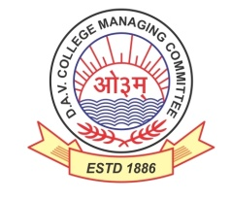
DAV HZL Sr. Sec. School dariba
rajsamand (raj.)

DAV HZL Sr. Sec. School dariba, rajsamand(raj.)

Split-up Syllabus
Class- III

Split-up Syllabus & Activities
for the session
2023-24
Class-IX

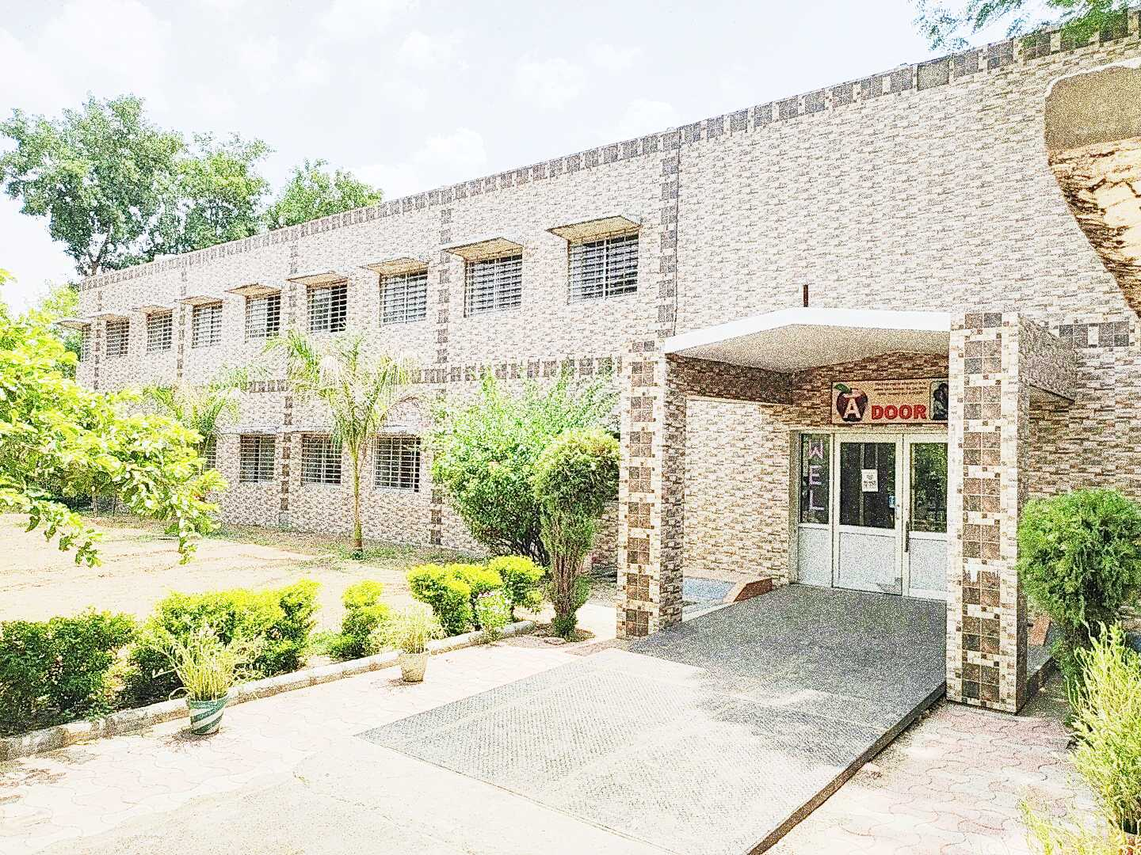

Address : Rajpura-Dariba, Distt. – Rajsamand (Raj.) 313211
Contact : (02952)265130 Email : davhzl_dariba@yahoo.com Website : http://www.davhzldariba.in
Subject |  | PT- I | PT- II
English |  | The Fun They Had, The Road Not Taken, Tenses | The Sound of Music, Wind,  Modals  Writing a Descriptive Paragraph (person/event/situation)
Hindi |  | f{kfrt & ikB~; iqLrd  izsepan & nks cSyksa dh vkRedFkk  dchj & lkf[k;k¡ | Ñfrdk & ikB~; iqLrd  ikB & 1 bl ty izy; esa  f{kfrt & ikB~; iqLrd  ikB & 2 & Ygklk dh vksj  ikB & 10 ok[k  vyadkj vkSj vukSipkfjd i=
Maths |  | Ch. – 1, 2 | Ch. – 3, 4, 6
Sci | Che. | Chapter – 1 | Chapter – 2
 | Phy. | Chapter – 8 | Chapter – 9
 | Bio. | Chapter – 5 | Chapter – 6
S.St. | Eco. | - | Chapter – 1
 | His. | Chapter – 1 | -
 | Geo. | Chapter – 1 | -
 | Civics | - | Chapter – 1
ICT |  | Unit – 3 | Unit – 6

Subject |  | Mid Term
English |  | The Fun They Had, The Sound of Music, The Little Girl,A Truly Beautiful Mind  The Road Not taken, Wind , Rain on The Roof, The Lake Isle of Innisfree  The Lost Child, The Adventures of Toto, Iswaran the Storyteller, In the kingdom of fools  Tenses, Modals, Subject-verb Concord  Writing a Descriptive Paragraph (person/event/situation)
Hindi |  | Ñfrdk & ikB & 2 esjs lax dh vkSjrsa  f{kfrt & ikB & 3 miHkksDrkokn dh laLÑfr] ikB & 11 loS;s] y?kqdFkk] vkSipkfjd bZesy laokn lwpuk ys[ku] O;kdj.k & milxZ] izR;;] vFkZ dh n`f"V ls okD; Hksn] vyadkj  ys[ku jpuk & vuqPNsn] i=]
Maths |  | Ch. – 1, 2, 3, 4, 5, 6,
Sci. | Che. | Chapter – 1, 2
 | Phy. | Chapter – 8, 9
 | Bio. | Chapter – 5, 6
S. St. | Eco. | Chapter – 2 & 3
 | His. | Chapter – 1 & 2
 | Geo. | Chapter – 1, 2 & 3
 | Civics | Chapter – 1 & 2
ICT |  | Unit – 2, 3, 6, 7, & 8

Subject |  | PT - III
English |  | The Snake and the Mirror,  A Legend of The Northland,  Reported speech, Diary Entry
Hindi |  | f{kfrt  ikB & 4 lk¡oys liuksa dh ;kn] ikB & 12 dSnh vkSk dksfdyk  milxZ] izR;;] vFkZ dh n`f"V ls okD; Hksn
Maths |  | Ch. – 11
Sci. | Che. | Chapter – 3
 | Phy. | Ch. – 10, 11
 | Bio. | Chapter – 15
S. St. | Geo. | Chapter – 4
 | Civics | Chapter – 3
ICT. |  | Unit – 9

Subject |  | Final Term
English |  | Complete Course (As per updated syllabus)
Hindi |  | lEiw.kZ ikB~;Øe $ O;kdj.k Hkkx $ ys[ku jpuk
Maths |  | Ch. – 1 to 12
Sci. | Che. | Chapter – 1 to 4 (As per Updated syllabus)
 | Phy. | Complete Course (As per updated syllabus)
 | Bio. | Chapter – 5, 6, 14, 15 (As per Updated syllabus)
S. St. |  | Complete Course (As per updated syllabus)
ICT. |  | As per CBSE Board

Exam | TENTATIVE DATES OF EXAM
PT – I | First week of May, 2023
PT- II | First week of August, 2023
MID – TERM | Mid September , 2023
PT – III | Last Week of November, 2023
FINAL TERM | Third Week of February, 2024

