CONGRATULATIONS !!!

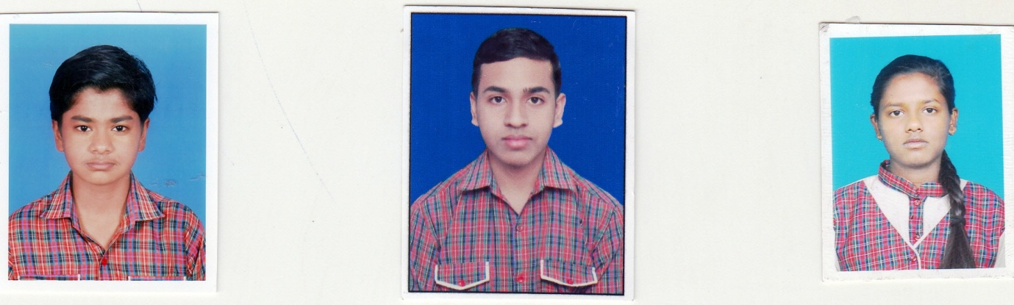
Winner of ISRO 2017 Space Quiz & Painting Competition
ARYAN KESHRI
AYUSH RAJ
RAKHI YOGMA

