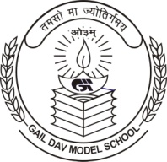
GAIL D.A.V. MODEL SCHOOL
GAIL Vihar, Dibiyapur, Distt. Auraiya (U.P.) - 206244.
Email: davgailvihar@gmail.com, gaildavdibiyapur@gail.co.in
==============================================================================
Ref: GAIL/D.A.V./Mod./ Date:

