D.A.V PUBLIC SCHOOL, EAST OF LONI ROAD
HOLIDAY HOMEWORK (2019-20)
CLASS II

Its time for your summer vacations….. It’s time for enjoyment but do remember that your study must not go for any vacation. So keep in touch of your studies also. And must complete your holiday homework.

ENGLISH
- Do 20 pages handwriting in a seperate notebook.
- Do 1 page reading every day.
- Make colourful cut-outs of any 5 nouns.
- Write ‘when to use Prepositions’ with picture on A4 sheet. (According to your Roll No.)
Roll No. 1-10 – In Roll No. 11-20 - On
Roll No. 21-30 behind Roll No. 31-40 Under
Roll No. 41-50 Above
- Learn all the new words of Ch 1- 4.
- Make sound butterfly on ‘ai ,ou ow and wh . ( A3 Sheet )
- Do dictation of 10 words every week.
- Read story books (Panchtantra, Champak etc.) and write down the nouns from it on colourful sheets.

MATHEMATICS
- Make a scrapbook, the cover page of which should be designed using 2D and 3D geometrical shapes.
- Complete your work with neat and legible handwriting.
- Make a wall hanging of tables 2- 10 .
Roll No. 1- 25 : Tables 2-5
Roll No. 26-54 : Tables 6-10
- Make a 3-D model of clock. And show the second, Hour and Minutes hand also on it.
- Make a chart of all the 2D shapes and also write its edges , vetices ,
faces etc with different colours.
- As practice make a man perfect so it is essential to do practice of questions everyday in your notebook.
- Do five questions of addition every day.
- Do fifteen questions of each of the following :
- ‘Before,
- ‘After’
- ‘Between’
- ‘Greater than’, ‘Less than’ and ‘equals to’.
Learn and write tables from 2 to 6 in your notebook
EVS
- Write down five features of this season (Summer Season) on A4 Sheet.
- Grow a plant and observe it. Write five steps you took to grow it. Write down your observation on A4 Sheet.
- Prepare a picture album of your favorite hill station collect pictures of the natural beauty of the place, dresses, weather, food etc. in EVS scrap file. Cover and decorate the scrapbook.
- Draw and write any five ways how you plan to clean your surroundings.
- Make a hygiene kit with the things you use for your cleanliness-like soap, Shampoo, hair oil, dettol, sensitizer, toothpaste, toothbrush etc.
- Revise all the chapters done in class

ART AND CRAFT
- Submit your Holidays Homework in a presentable manner as per the nature of the work e.g. a work which is three dimensional should be properly laminated) with name slip. Browse internet for innovative ideas. This will stimulate your imagination.
- Make a “Finger Puppet” with by Paper cutting & pasting etc. 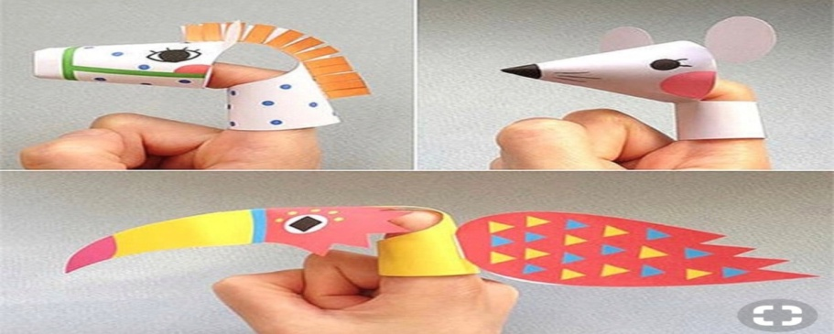
Or
Make a “Stick Puppet” with by Paper cutting & pasting etc.
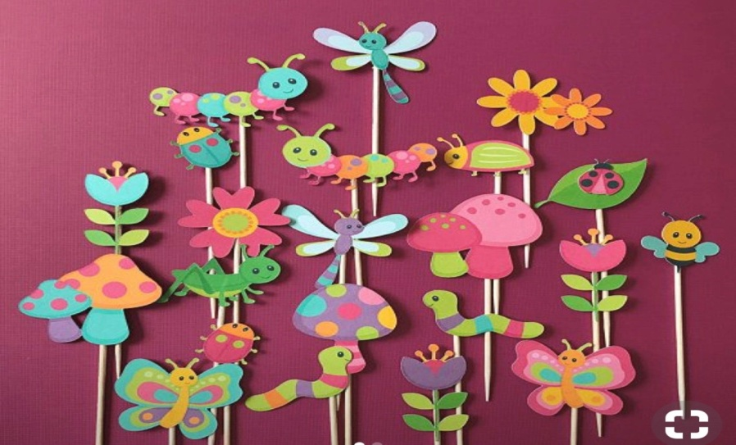

COMPUTER
a) Revise Chapter 1 and 2.
b) Make collage on Parts of computer on A4 size colored sheet.
GENERAL KNOWLEDGE
1. Do this on A3 chart during summer holidays.
2. Draw a traffic light. colour the lights correctly and state what each signal stands for
3. Write any five important things to be safe on the road. Take help from the G.K. Book.
4. Revise the syllabus done so far .

हिन्दी
निर्देश : १ सभी कार्य स्वच्छ्ता से एवं स्वयं करें ।
२ लिखित कार्य पुस्तिका मे एवं रचनात्मक कार्य ए-४ पर करें।
१. 15 सुलेख छोटी पुस्तिका में करो।
२ बाल पत्रिका पढ़ो और अपनी मनपसंद कोई एक कहानी लिख कर चित्र सहित बनाते हुए कहानी की शिक्षा भी लिखिए।
३ रसोईघर में प्रयोग होने वाली पाँच चीज़ों के नाम लिखिए, चित्र बनाइए अथवा चिपकाएँ।
४ एक से बीस तक हिन्दी में गिनती लिखिए।
५ कहानी पुस्तक (चंपक, नंदन,नाना-नानी की कहानियाँ, दादा-दादी की कहानियाँ इत्यादि।) पढ़िए और किसी एक पशु अथवा पक्षी का मुखौटा बनाएं।
नैतिक -शिक्षा
१- किन्हीं पाँच राष्टॄ पुरुषों या प्रेरणा स्रोतपुरुषों के चित्रों को चिपकाकर ,
उनके नाम लिखिए ।

