D.A.V PUBLIC SCHOOL, EAST OF LONI ROAD, DELHI-93
HOLIDAY HOMEWORK (2019-20)
CLASS VII
ENGLISH
Q1.In about 100 to 125 words, write a story of your own, giving the same a suitable and interesting title, using the following sentence in the middle of the same :
“ An old man came to the bridge and fed the animals……….”
Q 2. Design a short story poster project for ‘Avengers : End Game’ movie. And also write about your favourite character(s) with reasons for your liking. (in 100-120 words)
Q 3. Read any one book of your interest and prepare a jigsaw puzzle or any other board game from adjectives and adverbs you have come across.
Q 4. Revise the lessons which have been covered in the class and also prepare a folder to write the main idea and supporting details of each lesson in it. ( in 120-150 words for each lesson)

SCIENCE
A. Activities
1. Boil some water in vessel. Cover it with a plate. Remove the plate after sometime. Allow it to cool. We will see droplets of water on the surface of plate. Try to find out why and how these droplets are formed?
2. Take some moderately hot water in a tumbler. Dip one end of a steel spoon, plastic spoon, a glass rod, a wooden stick, copper rod in hot water. After waiting for a few minutes (2-3 minutes) carefully touch the other end of each item. Observe which one become hot or which one not? Then categorise them as heat conductors or as heat insulators.
Heat conductors | Heat insulators

3. Take three pots; fill them with sand, clay and loamy soil respectively. Sow wheat grains or green peas in each pot. water them regularly using the same amount of water for each pot. Record your observations about the growth of the plants. Write the conclusion on that basis.

B. Revise the chapters done in class till summer vacations.

C. Assignment (Do the following questions on science notebook)

- Why do we feel cold when our body sweats?
- Write difference between laboratory and clinical thermometer?
- How thermos flask keeps the liquids hot or cold?
- Name the following
  - Fastest mode of transfer of heat.
  - Mode of transfer of heat where no medium is required.
  - The metal used in the bulb of thermometer.
  - Mode of transfer of heat where the medium does not get heated.
  - A parasitic plant which is devoid of leaves, having yellow, slender tubular stem.
  - A solution used to test the presence of carbohydrates.
  - A plant that has both autotrophic and heterotrophic nutrition.
  - The by which organism obtain energy from the digested food.
- Why people advised to wear white clothes in summer?
- What is boiling point? What is the boiling point of pure water?
- What is land breeze? How it keep the land cool during the day?
- Mention the type of heat transfer in following:
  - Heating of water
  - Reaching of Solar energy to earth
  - Heating of iron rod
  - Sea breeze in coastal area
  - Cooking of food in utensils.
- Answer the following:
  - Which material has the highest melting point?
  - Which material has the lowest melting point?
  - What is the temperature range of laboratory thermometer?
  - What is temperature?
- What is soil? How is it formed?
- What is soil profile?
- Write the three functions of soil?
- Following are organic and inorganic constituent of soil. Classify them.
Dead and decaying plant matter, nitrate, phosphates, human excreta, carbonates, iron, sodium, dead microorganism.
- What is water retention capacity? Why it is important?
- What is deforestation? What are its causes?
- Why soil is important natural resources?
- Rearrange the jumble words to make suitable words related to soil and nutrition in plants.
  - MUSHU
  - RINGTHEEAW
  - FOLIRSESP
  - ORHSONI
  - TERUXET
  - ROPHYLCHLO
  - UNLISUNHGT
  - TERAW
  - TOSAMTA

SOCIAL SCIENCE
TASK-1
Create Manuscript
Make your own manuscript.
Take leaves and ink pen for writing the manuscript. Also make a beautiful cover page of your manuscript and use a ribbon for tying it up.
Answer the following:
Q:- How the earlier people wrote?
Q:- State the difficulties faced by you while writing the manuscript
Q:- Write down the difficulties storing the manuscripts.
Instructions-
(i) Paste the manuscript on scrap book carefully.
(ii) Write down the answers on scrap book.
(iii) Use your creativity while making the manuscript.
TASK-2
Survey
Name: ___________________ Locality: ________________Age: ______________
Family  Members | Age | Education  Qualification | Employed | Monthly income | Expectations from govt.
On the basis of the above format collect the information from different people (Postman, Police Officer, Lawyer, Engineer, Watchman, Vegetable seller etc.) of the society.
(Collect data from at least 10 people)
On the basis of information collected, prepare a report and analyze it to show the factors which lead to inequalities.
Instructions-
(i) Paste the form of survey in the scrap book.
(ii) Write down the report on the scrap book.
TASK 3
(a) Revise L-1 and L-2 of geography
(b) Revise L-9 and L-10 of History
(c) Revise L-18 of Civics
General Instruction:-
(a) Your holiday homework carries marks so submit your HHW timely i.e., 10th July,2019.
(b) The students will be assessed on the basis of presentation, creativity, originality, neatness, timely submission.
MATHEMATICS
(A) Represent the following rational numbers on number line:’
a) $\frac{-8}{7}$
b) 5$\frac{1}{3}$
c) -3$\frac{1}{2}$
d) $\frac{7}{9}$
e) $\frac{-8}{11}$

(Do it in your activity book)

B) Encircle mathematical terms in the following:

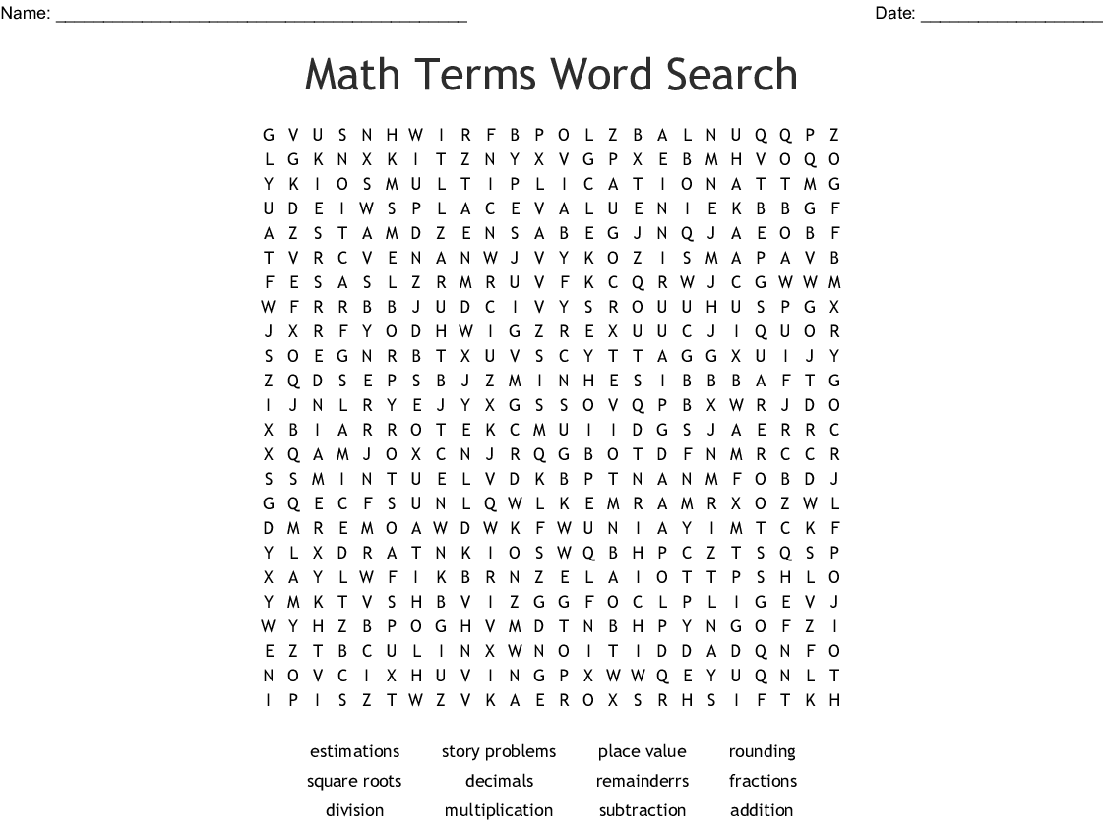
(C) General Instructions:
- Submit your work in a separate notebook.
- Practice ch- 1, 2 and 3 for periodic test 1.

Q1) Compare the absolute values of the following rational numbers:
$\frac{-8}{-9}$ and $\frac{-3}{9}$
Q2) On a number line, what is the length of the line segment joining $\frac{-1}{2}$and -2$\frac{1}{2}$ .
Q3) Write down the rational number whose numerator is (-3) × 4, and whose denominator is (34 -23) × (7 -4).
Q4) From a rope 11 m long, two pieces of lengths $\frac{13}{5}$m and $\frac{33}{10}$ m are cut off. What is the length of the remaining rope?
Q5) Express $\frac{-64}{256}$ as a rational number with denominator 8
Q6) Find the value of x :$\frac{15}{-x}$ = $\frac{1}{-7}$
Q7) Divide the sum of the rational numbers $\frac{3}{4}$ and $\frac{-5}{6}$ by the absolute value of their difference.
Q8) Find out three rational numbers between $\frac{2}{3}$ and $\frac{3}{4}$
Q9) Find the product of: $\frac{-3}{8}$and reciprocal of $\frac{6}{11}$.
Q10) Find the value of ($\frac{1}{x}$ ÷ $\frac{1}{y}$) ÷ (xy) if x = $\frac{3}{5}$ , y=$\frac{4}{3}$
Q11)With what number should we multiply $\frac{-36}{35}$ , so that the product be $\frac{-6}{5}$ ?
Q12) Find reciprocal of $\frac{-2}{3}$ × $\frac{5}{7}$ + $\frac{2}{9}$ ÷ $\frac{1}{3}$ × $\frac{6}{7}$
Q13) Express 4.82 as rational number in standard form.
Q14) Simplify and express as a rational number in its lowest terms:
a) 1.44 × (144 ÷ 12) - 0.225 + 3.276
b) $\frac{0.4 ×0.04 ×0.005}{0.1 ×10 ×0.001}$ - $\frac{1}{2}$ + $\frac{1}{5}$
c) $\frac{0.144+1.2}{0.016÷0.02}$ + $\frac{7}{5}$ – $\frac{21}{8}$
Q15)Simplify the following:
19.05 - [2.06 + {2.57 + (9.91 - 5.09 - 0.76)}]
COMPUTER
- Create a Tweak story/game
- Create illusion on scratch take the reference from following link:
https://scratch.mit.edu/projects/249202709/
3. Let’s think beyond books. (Do it on A4 size sheet)
- Which day is celebrated as world Computer Literacy Day?
- Who is known as the Human Computer of India?
- Mows is a type of mouse for ........ people.
- What do you call a portable computer?
  - What Is an icon?
  - Longhorn was the code name of ?
  - Which computer engineer got Nobel Prize for literature in 2003?
  - 'Do no evil' is tag line of ......
  - First Indian cinema released through internet is .....
  - Rediff.com was founded by..
  - Orkut.com is now owned by ....
  - Email was developed by......
  - When was the first smart phone launched?
ART
1)Make poster on A3 size sheet. Select any 2 topics from the following-
a)Corruption in India
b)The problem of poverty
c) Women empowerment d)Water problem
e)Childlabour
2) Prepare live scene with pencil shading on A3 size sheet.
3) Make some useful thing using waste material.

हिन्दी
१.मुहावरेबोलतेचित्रए४साइजशीटपरतैयारकीजिए। (कोईचार)
२. ए४साइजशीटपरदिएगएकिन्हींतीनविषयोंपरकवितासंकलितकीजिए।
विषय- समय, मित्रता, ईमानदारी, प्रकृति, आत्मविश्वास
३. व्याकरणिकपिटकबनाइए-,
जिसमेंवाक्यांशके लिएएक शब्द,पर्यायवाचीशब्द,विलोमशब्द , भाववाचकसंज्ञाशब्दआदिसम्मिलितहों।
४.ए-३ साइजशीट परसमाचारपत्रकेलिएएकबालकोनातैयारकीजिएजिसकेअंतर्गतकोईपहेली,चुटकलाकविता , रोचकतथ्यहों।
५. पाँचपृष्ठसुलेखकीजिएवप्रतिसप्ताह१०शब्दोंकाश्रुतलेखकीजिए।
६.कक्षामेंकरवायागयासमस्त पाठ्यक्रमयादकरें।

संस्कृतम्
छात्राः बुद्धिः, अभ्यासः, मित्रता, परोपकारः इति विषये श्लोकं लेखित्वा चित्रं निर्माणं कुरु।(A3 size Sheet)
१-१० संख्यानाम् प्रयोगम् कृत्वा कापि संख्या क्रीडा निर्माणम् कुर्वन्तु।
सप्ताहे द्वौ श्रुतलेखौ सुलेखौ च लिखत।
कक्षायाम् कृतकार्यस्य पुनरावृत्ति कुर्वन्तु।

नैतिक -शिक्षा
१- स्वामी दर्शनान्द या लेखराम ने आर्य समाज के प्रचार में क्या योगदान किया ?
इन्होंने आर्य समाज के प्रचार को व्यापक बनाने के लिए किया ।
अथवा
आधुनिक समाज में वैदिक धर्म , आर्य समाज के प्रचार की क्या आवश्यकता
है ? लिखिए ।

