D.A.V PUBLIC SCHOOL, EAST OF LONI ROAD, DELHI-93
HOLIDAY HOMEWORK (2019-20)
CLASS VI

ENGLISH
- Compose a poem dedicating it to your favourite
teacher . (Make a greeting Card and write the poem in it . )
- Gather information about any unique festival like ,HinaMasturi . And make a Pictorial file on it , covering (Name of the festival , Country , what they do , what they wear , food , and their belief about the festival ) . Make it look like a colourful expressive magazine .
- Read English Newspaper daily and find out 5 words which you find difficult , paste those words in the scrapbook and write their meaning . ( 5 words a week )
- Book Jacket : Read any 1 story book and Make its book cover on A4 sheet . Write the message which you get from the book .
- Make :
Roll No . 1-25 ( Flash Card of - Adjective )
Roll No 26- 55 ( Wall hanging of - Adverb )
- Visit any historical monument with your parents and write your experience .( Paste pictures also )
- Complete the story using your imagination in 50-60 words :
“One day I was alone at home and it was dark stormy night and then suddenly the door bell rang ………
MATHEMATICS
‘The best way to learn mathematics is to do mathematics.’ - Paul Halmos
NOTE: Question 1and 2 are to be done on a scrapbook
1.Define the following with suitable images to support the definition.
a) a plane surface
b) a curved surface
c) a ray
d) a line segment
(Hint: You can use images of sun’s rays, thread etc. for depicting the above)
2. Make a grid of numbers from 1 to 100. On it, shade all the multiples of 6 by colour blue and all the multiples of 7 by colour yellow.
(The common multiples will be the one shaded both colours i.e. green.
The highest common multiple will be the highest of these numbers.)
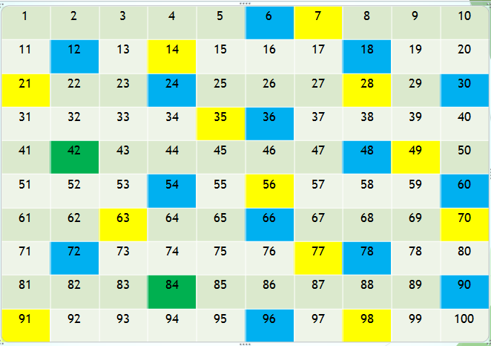
(From the table, we observe that 42 and 84 are common multiples of 6 and 7.
The lowest common multiple is therefore 42.)
3. Make 2 pictures with the help of Tangram .
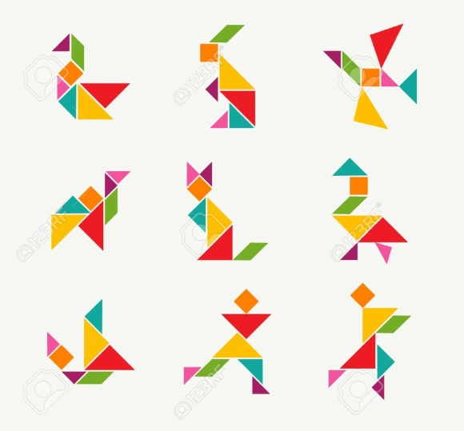

4.Print and solve the assignment given below and paste it in class work notebook.
ASSIGNMENT
Q 1 Find out the least possible missing digit in the place of *so that
(a)39*6 is divisible by 3
(b)12*2 is divisible by 4
(c)4*16 is divisible by 8
Q2. Find the greatest number that can exactly divide 140,170and 155 leaving remainder 5 in each case.
Q3. Find the L.C.M 80,120,135 by common division method.
Q4.Find the smallest number which when divided by 25, 45 and 60 leaves remainder 5 in each case.
Q5.Circle the even numbers and cross the odd numbers from the following:
42 , 57, 20009 ,1118, 57453 , 92346

Q6. Are the following numbers prime or composite. Show by finding the factors.
a) 42 b) 31 c) 63 d) 99 e)23 f)115

Q7. Write down all the prime numbers between 11 to 30.
Q8. List the factors of 18.

Q9. List the first five multiples of 19.

Q10. Which of the following are co-primes?
a) 13 and 14 b) 8 and 20 c) 31 and 59 d) 34 and 85

Q11.Write any two pairs of co-prime numbers.

Q12.Is 3955 divisible by 5 by using divisibility tests

Q13. Pick out the numbers that are divisible by 4 and 8
a)4924 b)63402

Q14.Test the following for the divisibility by 3 and 9
a) 294414 b)45404

Q15. Test the divisibility of 147246 by11.

Q16. Write the greatest 4 digit number. Express it as a product of primes.

Q17. Find the HCF of 204,144 and 252 using continued division method.

Q18. Find the LCM of 10 and 25 using prime factorization method.

SCIENCE
1. Revise CH: Our environment
Measurement and motion.
Nature of matter.
Project: 1 Take the measurement of your pencil box.
The length of shirt, length and width of collar ,of your shirt.
2. Segregate the kitchen waste and note down your observation into decomposable and non decomposable waste. Use the biodegradable waste in your flowerpots or garden
ACTIVITY: Take some pieces of news paper, pieces of cloth and used plastic bags. Burry these in soil and write your observations.
Organize a small debate on “Ban on plastic bags “ in your locality and list the points of view of different sections of people.

Work sheet.
1. How does nature maintains a balance , between amount of carbon-dioxide and oxygen?.
2. The group of organisms which use light for making food are known as…………….
3.How is vermicomposting useful for us ?
4 can we smell hot food from a greater distance? why ?
5. Define the term solubility .how does it change on increasing the temperature of water?
6. Write the importance of measurement in your daily life situation.
7. Identify the types of motion
1. Motion of a giant wheel
2. When we are pulling water from well.
3. Motion of nib of pen while writing.
8.Describe an activity to show the effect of temperature on solubility of substance.
8.form the food chain : owl ,grass hopper, grass, rat, snake
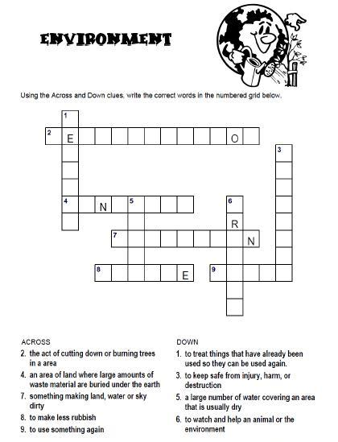

SOCIAL SCIENCE
Note:-Holidays Homework carries marks hence submission of work post vacation i.e 10th July is compulsory for all students.
1. The Holidays home work must be done in a very neat and presentable manner.
2. The child will be assessed for the presentation, neatness, completion of all the given questions and timely submission.
3. Submit all the work in Scrap book .
4. Revise all the chapters of Periodic test I.
1) For Roll No. 1 to 20 a) ‘ Tool making Activity’ Make any three tools using clay highlighting Neolithic or Mesolithic Age . The tools should be handmade having pointed/ flat//edge surface . Colour the tools to make it attractive and presentable.
b) For Roll No 21 to 35 Collect pebbles/ stones of different shapes and sizes . Paint pre- historic figures and animals on them. ( take reference from chapter 1 of history).
c) For Roll No 36 to 52 Make a handmade puppet representing any state of India in terms of looks, traditional dress and appropriate headgears and hairstyles.
2) Design aPreamble for your school abiding to all the rights and duties of all students in school. You can also take hint from preamble of ‘ Constitution of India’.
3)Collect andorganise information about your favourite freedom fighter in form of biography . Also discuss the traits of that person that you would like to imbibe and adapt in your life.
4) Paste five news items from the English newspaper concerning the following topics:
- Elections 2019 2) Environment 3) Science& Facts 4) Sports
5) Explore Delhi
Delhi latest tourist attraction embraces the seven wonders of the world . The ‘waste to wonder park’ featuring the replicas of seven iconic edifices from across the world has been opened in national capital. Visit this park with your parents and widen up your Knowledge base in context to seven wonders of the world.
All the students have to write detail account on any one world of wonder allotted to them .
- Great Wall of China (China) Roll no 1 to 8
- Christ the Redeemer Statue (Rio de Janeiro) Roll no 9 to 16
- Machu Picchu (Peru) Roll no 17 to 25
- Eiffel Tower Roll no 26 to 34
- Colosseum (Rome) Roll no 35 to 42
- Taj Mahal (Agra, India) Roll no 43 to 50
- Great Pyrimad of Giza Roll no 50 and above

ART
Complete Pg.No 30 to 34 of Step by Step
Create poster on topic ‘How to be cyber Safe’

.COMPUTER
WORKSHEET (on A4 size sheet)
Write a short note and stick pictures for the same : Charles Babbage, Lady Ada Lovelace, Herman Hollerith, Blaise Pascal
1. Charles Babbage: |  | ___________________________________________
 |  | ____________________________________________
 |  | ____________________________________________
 |  | ____________________________________________
 |  | ____________________________________________
2. Ada Lovelace : |  | ________________________________________
 |  | ___________________________________________
 |  | ___________________________________________
 |  | ___________________________________________
 |  | ___________________________________________
 |  | ___________________________________________
3. Blaise Pascal: |  | ________________________________________
 |  | ___________________________________________
 |  | ___________________________________________
 |  | ___________________________________________
 |  | ___________________________________________
Q2. Let’s think beyond books. (on A4 size sheet)
- The first page of a website is called the
- The first web based e-mail service ?
- Which paint program has Penguin as its logo?
- When was the first smart phone launched?
- Who invented Computer Mouse?
- What is Blue Brain project?
- What is three finger salutes?
- Who developed first portable computer?
- "Connecting people" is the tagline of ....
- i pad is manufactured by….
Activity:-
Create a photo album on Ms-Power Point
हिन्दी
१) कबीर, रहीम, वृन्दतथातुलसीकेकोईचारदोहेलिखिए । ,२) साक्षरता , पर्यावारण ,लड़्का-लड़कीहोतसमान ,अनुशासन, किन्हींदोविषयोंपरदो-दोस्लोगनतैयारकीजिए ।
३) प्रतिसप्ताहएकसुलेखलिखिए ।
४) प्रतिसप्ताहदसशब्दोंकीश्रुतलेखकीजिए।
५) किसीरोचककहानीकोचित्रकथाकेरुपमेंतैयारकीजिए।
६) बालफ़िल्म ‘बाजा’ देखिए।
कार्यस्वच्छतासेकरें।
प्रश्न १और २ ए-३ शीटपरकरेंतथाप्रत्येकदोहाऔरस्लोगनअलग-अलगशीटपरकरें।
प्रश्न ३और ४ छोटीपुस्तिकामेंकरें।
चित्रकथाफ़्लैशकार्डपरतैयारकरें।
संस्कृतम्
भवन्तः मित्रता विषये कथाम् कक्षायाम् अपठन्, मित्रता विषये एकाम् नवीनाम् कथाम् संस्कृते लिखन्तु, चित्रम् अपि अङ्कितं कुर्वन्तु।
कक्षायां निर्माणं चित्र सहितम् कुरुत। (A3 size sheet)
१-१० संख्यानाम् प्रयोगम् कृत्वा कापि संख्या क्रीडा निर्माणम् कुर्वन्तु।
सप्ताहे द्वौ श्रुतलेखौ सुलेखौ च लिखत।
कक्षायाम् कृत्कार्यस्य पुनरावृत्ति कुर्वन्तु।

नैतिक -शिक्षा
१- स्वामी श्रद्धानन्द या महात्मा हंसराज ने आर्य समाज तथा शिक्षा के लिए क्या
कुछ किया ? तीन पेज या चार पेज लिखिए ।

