DAV PUBLIC SCHOOL, EAST OF LONI ROAD
HOLIDAY HOMEWORK
CLASS- V
ENGLISH
Writing poetry is to celebrate, commemorate or capture your own feelings. Compose a poem on the given topics in about 10-12 lines. (any 1)
- Friendship
- School life
Do it on an A4 size sheet. Be innovative, use pictures.
- Books are known to be our best friends. Cultivate the reading habit to become knowledgeable and thoughtful.
Read the following books and write a character sketch of any character you liked the most.
- Alice in Wonderland.
- Fire on a Treasure Island
- Oliver Twist
- The Adventures of Sherlock Holmes.
- The Adventures of Rusty.
Draw the picture of the character and write a few lines about it (80-100) words. Do it on an A4 size sheet.
- Interview the person who has inspired you the most in your life may be your parents, grandparents or neighbours. Prepare a questionnaire and fill it by interacting with them. Do it on an A4 size sheet.
- Go green
Prepare a book mark by recycling the waste material. Write a slogan related to ‘Save Environment’ on it.
- Read the newspaper daily. Pick out new words from it and prepare your own dictionary of around 200 words.
- Use the following abstract nouns to write a paragraph in about 100-120 words.
Brilliance, courage, determination, honesty, loyalty, tolerance, wisdom, wit, anger, friendship, patience, talent, helpfulness, pleasure, uncertainty, ability, dreams, imagination, speed, creativity.
Do it on an A4 size sheet.
MATHEMATICS
Its time for your summer vacations….. It’s time for enjoyment but do remember that your study must not go for any vacation. So keep in touch of your studies also. And must complete your holidays homework.
Instructions:
- Make a scrapbook the cover page of which should be designed using geometrical shapes.
- Complete your work with neat and legible handwriting.
Q 1. Note down the maximum temperature of five consecutive days in Celsius and convert into Fahrenheit unit. Paste the cutting of temperatures printed in the newspaper.
Q 2. Make a foldable to show the operations on large numbers (Properties).
Q 3. Do shopping with your parents and collect at least 3 bills and paste them in your scrapbook. Find the total amount of your bills also.
Q 4. Make a Place Value Slider by using different colour thick sheets.
Solve the following questions :
Q 5. Fill in the following blanks :
i. Temperature is the measure used to check _______ and _______of a body.
ii. The instrument used to measure temperature of a body is called ________.
iii. The temperature of a healthy adult is_____˚ F.
iv. _____ is the freezing point of water in Celsius Scale.
v. _____ is the boiling point of water in Fahrenheit Scale.
vi.A ________ can keep a track on day to day sales with the help of bill.
vii.The ____________ can cross check the prices of items purchased and their total cost with the help of bill.
viii.A shopkeeper prepares a ____ for customer.
Q 6. Convert the following temperatures into the other scale :
i. 95 ˚F
ii. 10 ˚C
iii. 25 ˚C
iv. 122 ˚F
Q7. Prasant runs 9,230 meters daily in the morning. How many meters he runs in one year? Convert your answer into kilometers.
Q8. Find the value of 8,90,348 + 1,02,213 – 78,990.
Q9. Look carefully at the bill given below and answer the questions that follow:
Ph 2342325 Raj Book Shop Date 8-11-2015
Kamla Nagar, New Delhi
SNo. | Item | Quantity | Rate | Amount
1  2  3  4 | Eraser  Notebook  Poster Colour  Gel Pens | 2  5  1  4 | 5.00  40.00  80.00  10.00 | 10.00  200.00  80.00  40.00
Total |  |  |  | 330.00
a. What is the name of the Shop?
b. How many Items were purchased from Raj Book Shop?
c. What is the cost of 1 Gel Pen?
d.What is the cost of 2 erasers?
e.What is the total cost of the items purchased?
f.What is the address of the shop?
COMPUTER
Q1 .Fill in the blanks: (To be pasted in notebook)
- The_____ are used in big hospitals, airlines and banks
- __________supercomputer covers a space equal to two basketball courts
- ___________is an example of mainframe computer.
- __________ memory is of two types.
- An animation can be repeated________ times.

- ________is the PC which is kept at one location and is not portable.
- _________computers are worn on body
- The bar code reader is also called as_______ scanner.
- Input and output devices connected to a computer are called_______device.
- We can also add sounds or movies from a_____ or from a _____.
- To insert our own voice,we need to attach a _______to computer.
- A__________________ is the effect that we see as the slide changes over.
- The data stored in______ memory can not be directly accessed by CPU.
- _____________ are the fastest computers.
- 1024 bytes=_____kb
- Primary Memory is of two types which is _______and_____.
- Movies can be inserted from______ and__________.
Q2.Guess my name.
- I store the photographs electronically and not on a photographic film.
- .I am used to show a PowerPoint presentation on a large screen.
- I am permanent memory and non-volatile in nature.
- I am an output device used to produce high quality and accurate drawings.
- I am temporary memory and volatile in nature.
- I am a minicomputer used as a server in networks.
- I am the effect that appears when the slide changes over.
- I store data which is not needed frequently.
Q3.Give the full forms of the following.
a) POS | i) | MICR
b) LCD | j) | LCD
c) KB | k) | PDA
d) MB | l) | CAD
e) CD | m) CAM
- RAM
- ROM
- OMR
Activity:
- Create a photo album on Ms-Power Point
- Learn and write shortcut keys on Ms-Power Point( on A4 size sheet)

ART & CRAFT
Submit your Holidays Homework in a presentable manner as per the nature of the work e.g. a work which is three dimensional should be properly laminated) with name slip. Browse internet for innovative ideas. This will stimulate your imagination.Design “Paper Weight” with by Stone Painting Art Technique with inspiring Thought (Power of Word) on it etc.

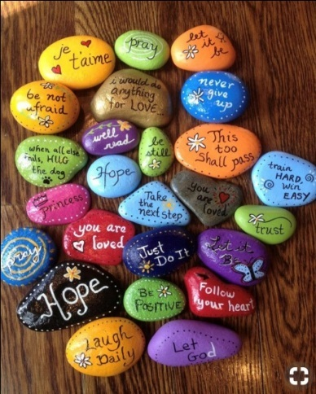
Or
Make a “BIRD HOUSE”
Take a tin/ plastic box; make a hole in it, like an entrance. Make a hook on top of it with a metal wire for it to be hanged easily. Color and decorate according to your choice.

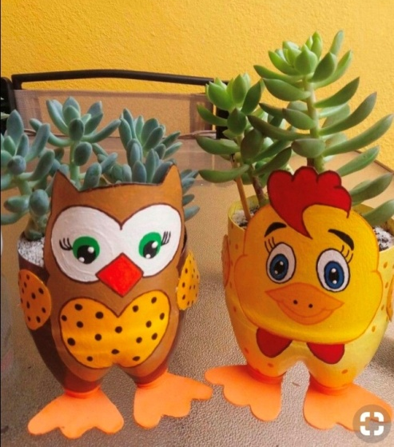
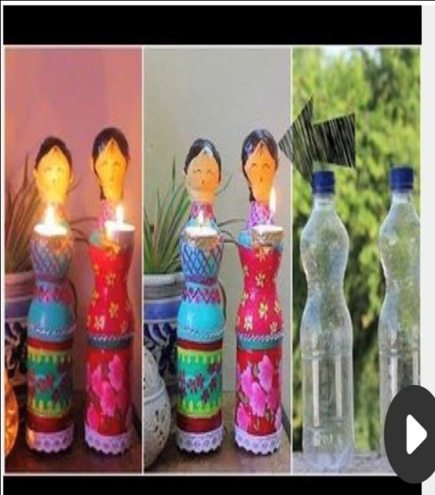

हिन्दी
* सप्ताह में दो सुलेख लिखें।(छोटी पुस्तिका में)
* नैतिक शिक्षा ,चपंक तथा अन्य पत्रिका में से कहानियाँ पढ़ें ।उनमें से आपको कौन सी कहानी सबसे अच्छी लगी ?उससे क्या शिक्षा मिली अपनी पुस्तिका में लिखें ।(छोटी पुस्तिका में)

*शब्द कोश निर्माण: प्रतिदिन समाचार पत्र पढ़ें।प्रतिदिन दो नए शब्द छाँटें और उन्हें अर्थ सहित लिखें।
*कोई एक चित्र कथा संवाद शैली में फ्लैश कार्ड पर बनाइए।

* विज्ञापन निर्माण:
१-२०( पौष्टिक भोजन)
२१-४०( बेटी पढ़ाओ,बेटी बचाओ)
४०-५५( योग अपनाएँ)(ए-३ साइज शीट पर)
* हिंदी पचाँग के अनुसार महीनों के नाम चार्ट पर लिखिए।
* मुहावरा पटिका बनाइए। प्रत्येक विद्यार्थी पाँच-पाँच मुहावरे बनाएगा)
१-१०( आँख पर)
११-२० (नाक पर)
२१-३०( कान पर)
नोट:- कार्य स्वच्छता से कीजिए।
३१-४० (गिनती पर)
४१-५३( पैरों पर)
संस्कृतम्
शब्दकोषस्य निर्माणं कृत्वा तेषां नामानि संस्कृते लिखत ।
सप्ताहे द्वौ श्रुतलेखौ सुलेखौ च लिखन्तु।
पञ्च चित्राणि अङ्कितं कृत्वा मञ्जूषा निर्माणं कुर्वन्तु।
कक्षायाम् कृत्कार्यस्य पुनरावृत्ति कुर्वन्तु।

नैतिक -शिक्षा
१- लाला लाजपत राय या भगत सिंह ने देश और आर्यसमाज के प्रचार के लिए
क्या क्या किया ? तीन पेज में लिखिए ।

