DAV PUBLIC SCHOOL, EAST OF LONI ROAD
HOLIDAY HOMEWORK
CLASS- IV
ENGLISH
- Say farewell to the notebook cover that looks like everyone else’s. Be innovative and design your own notebook cover for your English notebook using bright yellow colour sheet. Use proverbs or quotations to make it look attractive.
- Homophones- Homophones are pairs of words that sound the same but have distinctly different meanings and spellings. e.g. Tail – tale.
Pick any two homophones and display them in 3-d form.
- Read a book of your own choice. Pick any 1 character from it. Draw it on A3 size sheet and write the adjectives used to describe that character.
Suggested readings-
The Jungle Book
Little Red Riding Hood
Panchtantra Tales
- Revise Unit-1 thoroughly for the 1st Cycle Test (2019-20).

EVS
Do all the work neatly in your science notebook.
1.The World Environment Day is on 5th June. Adopt a plant near your house or grow a plant in a pot and place it in your house. Do the following to take care of your potted plants.

a. Water your plant daily.
b. Keep the plant near the window for proper sunlight.
c. Provide it good manure.
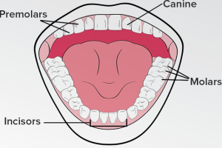
2. A face looks beautiful with the shining and bright teeth. We eat food with the help of our teeth. Take an apple and stand in front of the mirror. Take a bite and find out the following:
a. Which teeth did you see to bite?
b. Which teeth did you use to chew?
c. Which teeth did you use to crush?

3. Prepare a Balanced Diet chart for children between the age group of 1-12 years. The diet chart should clearly mention the different types of seasonal and economical food items, which are nutritious and not junk and that can be consumed in breakfast, lunch and dinner. Paste related pictures to make the diet chart attractive and informative. Use A3 size sheet for the above activity.

4. Collect the contact no. of the fire station, police station, doctor, chemist and a hospital near your house. Note down the numbers neatly in your notebook.
5. Learn difficult words of Lesson-1 and Lesson-2. Also prepare for upcoming periodic cycle .
SOCIAL STUDIES
A.Create a family book---- covering the following information.
1.Name of the family member ______________
2. Relationship ________________________
3. Career path___________________________
4. Values you admire in him or her 1__________________2.__________________3._______________
5.One sentence of your own choice.__________________________
________________________________________________________
B. “ Read the chapter 1-3 of your text book, find the names of states while reading , make a note of them .Collect the Information on any one state of your choice in a booklet form under the following headings :-
1. Name of the selected state.
2. Location of the state on the map of India.
3. Climate
4.Language
5. Food
6. Famous places.
7. Any other information of your choice.
( Paste the relevent pictures with the information)
C. “PUT THE RIGHT KIND IN RIGHT BIN” Make samples of two types of garbage collection bins in green and blue colour for your “Ideal Home” and paste them with its relevant information on card board . (Use waste material and your own imagination to make it purposeful.)
MATHEMATICS
‘The best way to learn mathematics is to do mathematics.’ - Paul Halmos
Instructions:
- Make a scrapbook, the cover page of which should be designed using 2D and 3D geometrical shapes.
- Complete your work with neat and legible handwriting.
- Healthy body is essential for each and every human being. Hence to keep your mind, body and soul fit one should adapt practicing physical activities on a regular basis. You are required to maintain a table in your scrapbook for recording :
the total number of skipping done with the help of a skipping rope every day for 10 consecutive days .From the table, answer the following-
- Write the numbers in ascending order.
- Write the numbers in descending order.
- Write number names of each number.
- What is the greatest number?
- What is the smallest number?
- What is the product of the greatest and smallest numbers?
- Make a formula booklet containing tables up to 20 and properties of addition, subtraction and multiplication.
- Practice the content done in the class for your first cycle test.
- Make a geometrical rangoli in your scrapbook.
- Print and solve the worksheet given below and paste it in class work notebook
WORKSHEET 1
Solve the sum. Then find them answer in user word.
- 680 - 480 =_____ e) 70×1= ____
- 8000 ÷100 =_____ f) 4280 – 4260 = ____
- 10 × 10 × 1=_____ g) 330 + 1 – 70 = _____
- 6000 – 5950 = _____ h) 60,000+40,000= _____

T | P | S | E | V | E | N | T | Y | D | F | H | H | F | H | F
W | J | E | I | H | J | F | C | H | B | I | M | X | R | F | I
O | K | N | G | M | P | M | P | Q | A | F | L | A | M | L | V
H | F | G | H | G | I | N | O | W | S | T | K | S | N | K | E
U | H | D | T | H | T | W | E | N | T | Y | J | D | H | J | H
N | D | H | Y | U | Y | B | I | E | S | F | H | F | U | H | U
D | D | J | M | H | O | N | D | R | E | D | G | G | N | G | N
R | D | K | H | G | T | V | U | R | V | R | F | H | D | F | D
E | G | L | A | K | H | C | Y | T | E | E | D | J | R | D | R
D | H | F | X | D | E | X | T | Y | N | W | S | K | E | S | E
J | Y | Y | B | B | W | Z | R | Y | T | Q | A | L | D | A | D

WORKSHEET 2
Q1. Fill in the blanks:-
- 4526 + 127 = _________ + 4526
- 79167 + __________ = 79167
- 96125 - 0 = ________
- 8218 – 8218 = ________
Q2. Answer the multiple choice questions (M.C.Q):-
- 5775 + 0 is
- 0 (b) 5775 (c) none of them
- 37251 + 98 = _________
- 37349 (b) 72349 (c) 27398
- 9000 – 4000 = ________
- 5000 (b) 4000 (c)3000
- Predecessor of 94875 is
- 94876 (b) 94874 (c)94879

ART & CRAFT
Submit your Holidays Homework in a presentable manner as per the nature of the work e.g. a work which is three dimensional should be properly laminated) with name slip. Browse internet for innovative ideas. This will stimulate your imagination.
Make a “Study Table Utility Box” Ex Pen Holder ,Stationery Container using waste material.
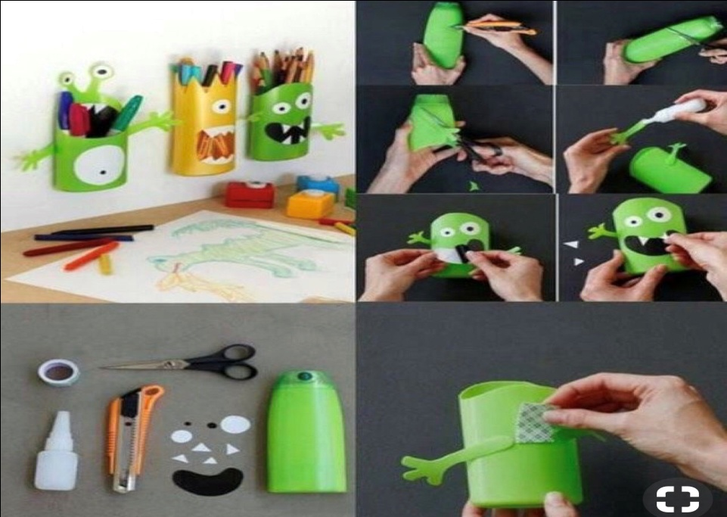
Or
Make a “Flower Bunch”--Take one dry bush of approximately 18 inches, fix it in a cup using POP. Color and decorate it using pomp pomp balls, beads, flowers, origami, etc.
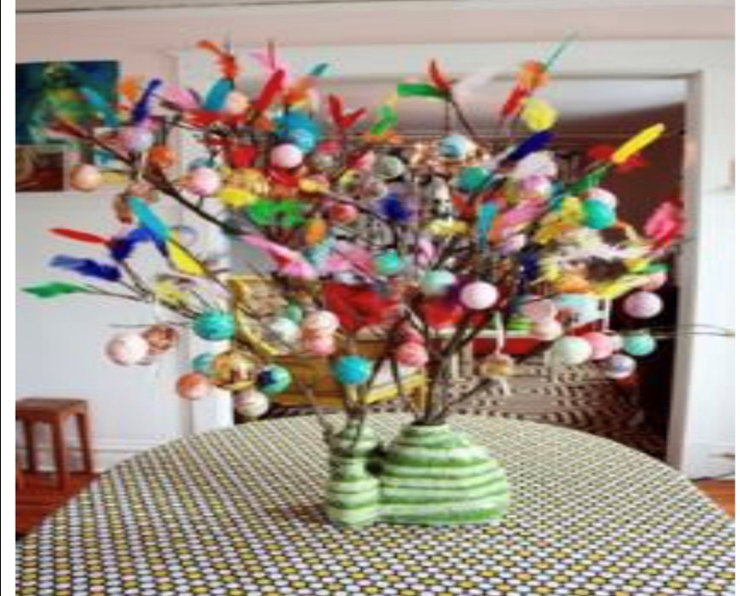

COMPUTER
a)Revise Chapter-1.
b)Make cutouts of Input and Output devices using cardboard.

हिन्दी

* दससुलेखलिखें।
*नंदन,चपंकतथाअन्यपत्रिकामेंसेकहानियाँपढ़ें।उनमेंसेआपकोकौनसीकहानीसबसेअच्छीलगी?उससेक्याशिक्षामिलीअपनीपुस्तिकामेंलिखें।
*शब्दकोशनिर्माण: प्रतिदिनसमाचारपत्रपढ़ें।प्रतिदिनतीननएशब्दछाँटेंऔरउन्हेंअर्थसहितलिखें।
विषय: संज्ञा:-संज्ञाशब्दोंकोदर्शातेहुएवर्गजालबनाइए।(ए४शीटपर)
* हमारेराष्ट्रीयप्रतीकोकोचार्टपरसचित्रदर्शाएँ।
* छुट्टियोंमेंआपअपनेआस-पासकेकिसीपार्कयाबगीचेमेंजाइए।वहाँकेमालीसेविभिन्नपेड़ोंकेबारेमेंजानिएऔरउनकीपत्तियाँएकत्रकीजिए।उन्हेंस्क्रैपपुस्तिकामेंनामसहितचिपकाएँतथाउनकीउपयोगिताकेबारेमेंलिखिए।
* नोट:-प्र१,२ छोटीपुस्तिकामेंतथासमस्तकार्यस्वच्छ्तासेकरें।

नैतिक -शिक्षा
१- महात्मागाँघीयामहारानीलक्ष्मीबाईनेदेशकेलिएक्याकुछकिया ?
दोपेजमेंलिखिए।

