DAV PUBLIC SCHOOL, EAST OF LONI ROAD, DELHI
HOLIDAYS HOMEWORK (2019-2020)
Class I

Its time for your summer vacations….. It’s time for enjoyment but do remember that your study must not go for any vacation. So keep in touch of your studies also. And must complete your holidays homework.
E.V.S
LET’S GIVE SUMMER A BIG FAT CHEER!
- Paste wrappers of any 10 junk food with their names on chart.
- Prepare wall hanging on types of clothing.
- Paste picture of every family member and write 3 qualities about them in scrapbook. Cover and decorate the scrapbook.
- Prepare toran with pictures of healthy foods along with their names.
- Make a badge with your name and picture.
- Prepare handmade photo frame of a picture of your family outing.
- Grow a plant and observe it. Bring it in school. Paste picture of you growing the plant in scrapbook.
- Ask your parents about your one favourite plant and write 5 sentences on it in scrapbook.
English
- Read chapter 1 to 5 from English reader.
- Read any English newspaper/book/magazine and write 10 ee ,ll, oo, sh, ch sound words from them in Scrapbook. Cover and decorate the scrapbook.
- Draw picture of the object on the cardboard given below:-
Moon , sun, metro rail, flower, camera or any other object of your choice and characterise yourself as the object choosen in the classroom.
- Paste pictures of any 20 opposite words pair in scrapbook.
- Do dictation from chapter 1 to chapter 8 in holiday homework notebook once in a week.
- Make toran using sound words of each ee, ll, sh, oo, ch sounds separately. (Example of shapes for toran – Glass, butterfly, bangles, flower, train, clouds etc.)

हिन्दी
- क से ज्ञ तीन बार लिखिए।
- पाँच सुलेख लिखिए। ( दो, तीन, चार अक्षर वाले शब्द आ और इ की मात्रा )
- तीन श्रुतलेख लिखिए। (( दो, तीन, चार अक्षर वाले शब्द आ और इ की मात्रा)
( कार्य पुस्तिका में कीजिए)
- अ, आ, इ मात्रा वाले शब्दों के चित्रों का कोलाज बनाएँ । ( ए३ शीट पर)
- कोई एक कविता हाव- भाव के साथ याद कीजिए।
- मेरी पाठशाला पर पाँच वाक्य याद कीजिए।
- रचनात्मक कार्य----------
- अच्छी आदतों से संबंधित चार बड़े रंगीन चित्र बनाएँ तथा एक-एक वाक्य भी लिखें।
( रचनात्मक कार्य ए-३ शीट पर करें। एक शीट पर एक ही चित्र बनाएँ )
- ऐसे दो अवसर सोचिए जिन्हें आप सब लोगों के साथ मनाते हैं, अकेले नहीं। अपने जीवन में आए इन अवसरों की फोटो पुस्तिका में चिपकाइए।
MATHEMATICS
INSTRUCTIONS
- Make a scapbook, the cover page of which should be designed using 2D and 3D geometrical shapes.
- Complete your work with neat and legible handwriting.
- Practice all operations from 1-20 (after, before, between numbers) in notebook. Do 10 questions of every concept.
- Make your own colorful telephone directory. Write the name and phone number of your parents, grandparents, uncle/aunt, friends, school etc.
- Learn your residential address and mobile number of your parents.
- Make a beautiful model of clock with moving hand.
Or
Make a model of Abacus using different colors of beads. Red beads for Tens place and white beads for Ones place.
- Make a number card (size 6’ x 6’) according to your roll no.
1 – 10 of numbers (1-20)
11 – 20 of numbers ( 21-30)
21-30 of numbers ( 31-40)
31-40 of numbers ( 41-50)
41-52 of number (51-60)

Fun and creativity with shapes---
- Make scenery or the figure of a clown using various shapes such as –square, circle, triangle, oval etc. Use different colored glaze paper for the shapes.
(Note- To be done on A4 size sheet.)
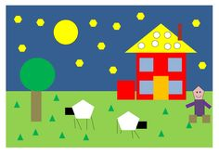

Art & Craft
Submit your Holidays Homework in a presentable manner as per the nature of the work e.g. a work which is three dimensional should be properly laminated) with name slip. Browse internet for innovative ideas. This will stimulate your imagination.
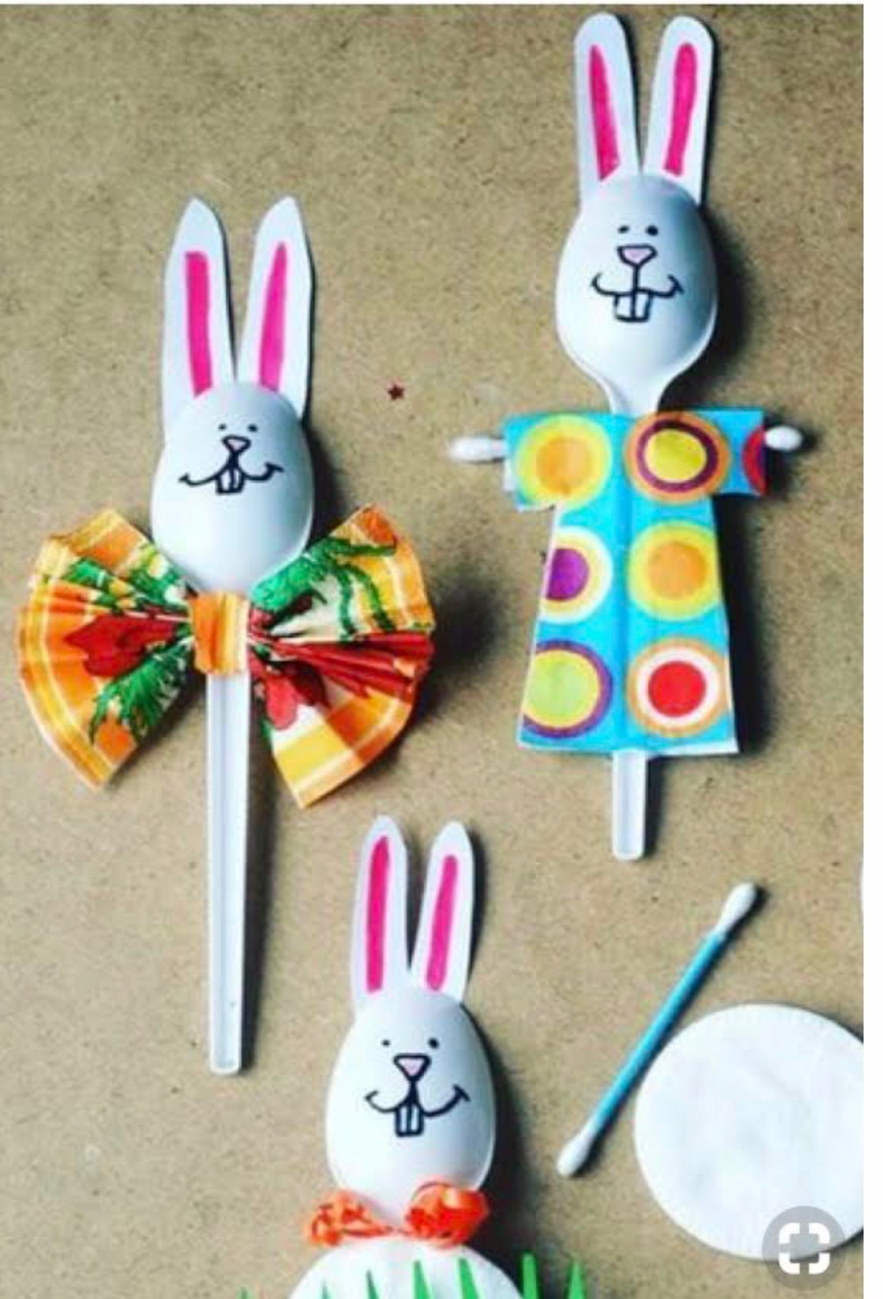

Make a “Plastic Spoon Puppet” by Paper Cutting & pasting etc.
Or
Take one paper and cover it with ice cream sticks. Try to make any easy drawing using water colors and sketch pens over it. Attach a thread loop to make it hang on the wall.
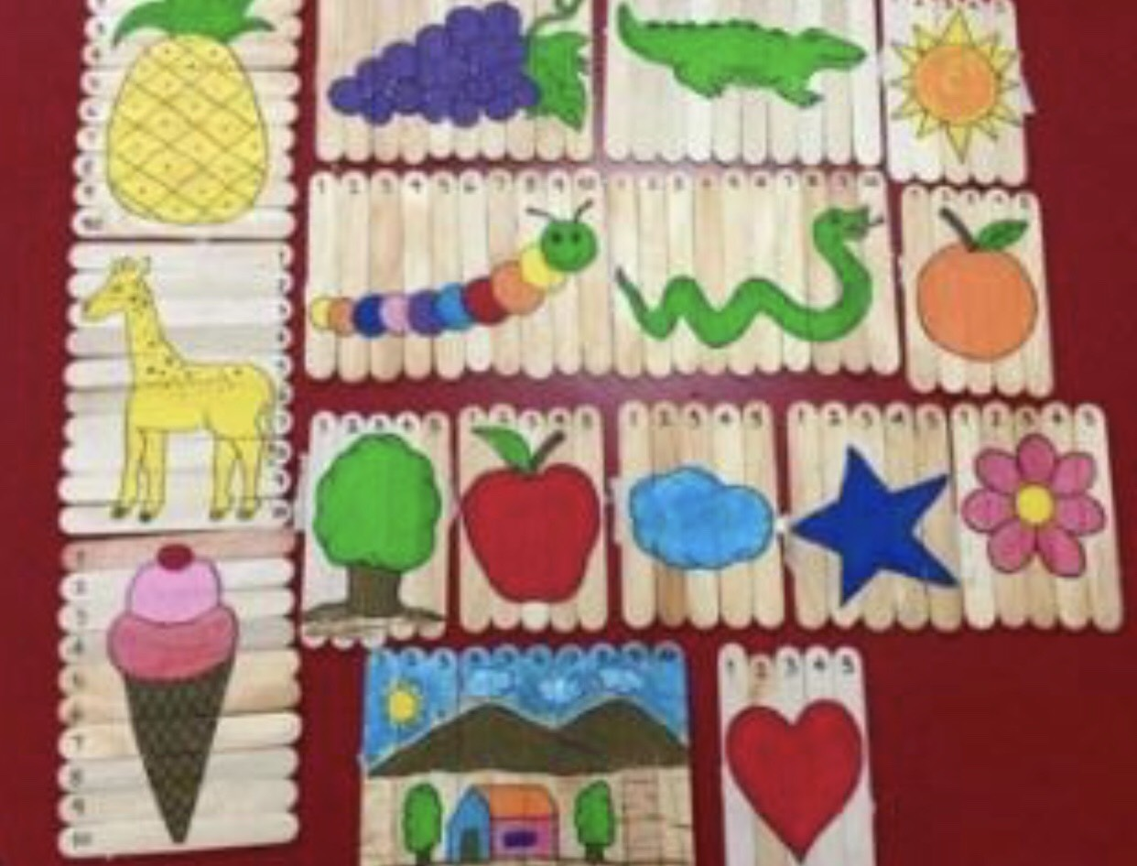
COMPUTER
- Revise chapter-1 and 2.
- Wall hanging of Parts of computer.
- Observe the machines near you which runs with the help of electricity.

नैतिक -शिक्षा

१- पाठ १ , २ , ३ में से किसी एक पाठ का शीट पर चार्ट बनाकर लावें ।

