D.A.V. PUBLIC SCHOOL
East of Loni Road, Delhi – 93
Holidays Homework
Dear Parents,
The vacations are here again, bringing with it the gift of togetherness
that is spent in exploring books, storytelling and playing games. These days are
precious and invaluable standing out as the most memorable days of childhood.
Let this be a time for enjoyment & relaxation. But don’t forget to blend fun intelligently with creative work. Following are the few summer activities:

Activity 1 -Pressed Flowers and Leaves Card
Make your child collect attractive leaves and flowers which have fallen down and make sure that your child does not pluck flowers or leaves.
Let them dry in between a heavy book and make beautiful card out of those dried down leaves and flowers.

Activity 2- Plant a sapling
Plant a sapling on June 5 that is world environment day, and click a picture of yours with your plant

Activity 3- Experiment
Freeze colorful ice using food colors and add them in rose syrup. As the ice cubes will melt the drink will change the color.

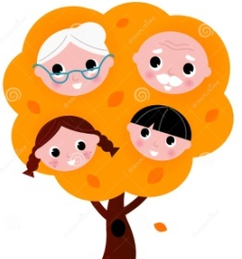
Activity 4 – Make a Family Tree
Make a family tree showing the following:
a) Names of the family member
b) Their favourite pet animal
c) What they like to eat / drink

Activity 5 – Flash Card making
Make Alphabet flash card with a letter in the front and a picture in the back. Learning the ABCs is fun and easy with this teaching tool. Alphabet flash cards help children develop memory & listening skills. Children will get to know phonics & be able to connect letter sounds with objects, for example: A is for Apple
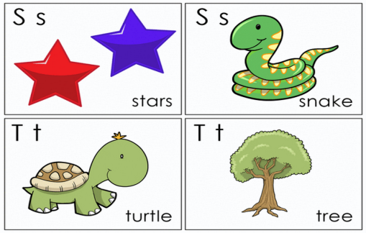
In the same way make number flash cards
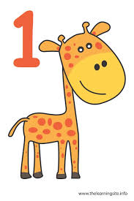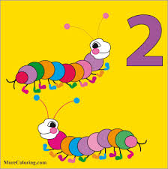

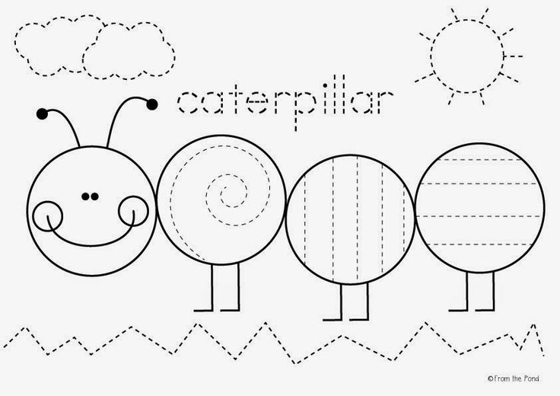
Activity 6 -Trace the curves and color the sun, grass, clouds and face of the caterpillar.
Routine Chart
- Go for a morning & evening walk daily with your child. Please don’t break his routine of getting up early in the morning and doing prayer.
- Help your child in attaining beautiful handwriting.
- Let him do picture reading daily and develop his liking for books
- Enrich your child’s vocabulary by teaching him new words daily.
- Go for cycling or help him/her in learning various activities like cycling, skating, swimming, etc
- Give away toys and clothes you do not need.
- Encourage your child to converse in English, speak English sentences daily at home.

HAPPY HOLIDAYS





