D.A.V. Public School East of Loni Road, Delhi-110093
Class – Pre-Primary
SUMMER PLANNER 2019-20
“Success is the sum of small efforts repeated day in and day out”.
Summer Vacations are synonymous with fun, frolic, getting up well relaxed in the morning, playing for longer hours with friends, going for picnics, exploring new places and watching fun filled shows on television. But dear children, there is a lot more you can do to make your vacations more interesting, meaningful and full of fun; along with doing all your heart desires. Here is a “summer vacation Activity Treasure Box” just for you. It will surely mould you for a better and successful forthcoming year. So get ready for your treasure hunt.

Creative Corner
- Activity 1- Read a picture book and transforms a book character into a beautiful hand puppet using paper bag or socks.
- Activity 2 – Visit any place of your liking. Either pick any interesting item of handicraft from their or prepare one of your own.
- Activity 3- Go outdoor enjoy the nature with a bird book and see if you can find that are in that book. Feed and give water to birds and stray animals, under the supervision
- Activity 4 - Plant a seed in a glass container so that you can see the root system.
- Activity 5 – learn and write your phone number in the boxes given below:-
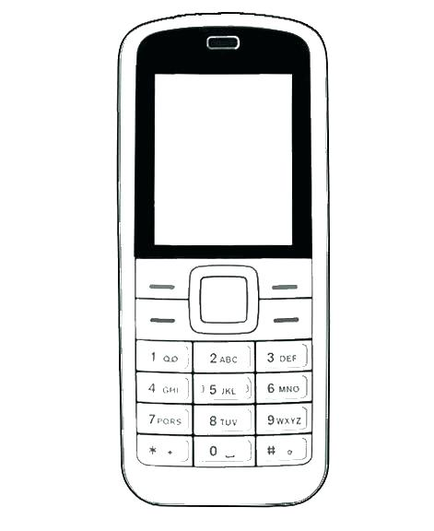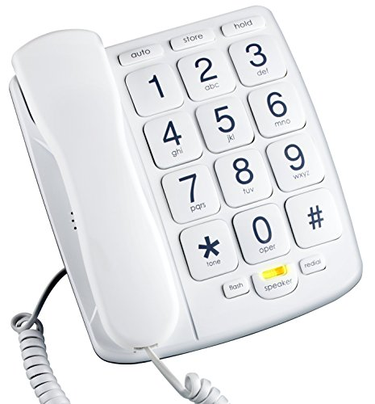
Practice dailling the numbers by pressing the keys.

HOW TO HAVE A FRUITFUL SUMMER BREAK

HEALTH IS WEALTH:
- Rise early to catch the sunrise daily .
- Go for morning walk with your family.
- Drink plenty of fluids like lemonade, buttermilk, milk shakes etc. to keep yourself cool.
- Restrict your television time to 1 hour a day and watch good children’s programme, cartoon films, Discovery channel, National geographic channels etc.
- Practice simple yoga asanas at home with your parents.
- Minimize the use of electronic gadgets.
NATURE CARE:
- Adopt a plant, water it daily. Nurture and watch it grow.
- Ask your parents to help you plant trees in your neighbourhood.

DEVELOPING SOCIAL SKILLS :
- Adopt the magic words like – Please, Thank you, Sorry etc. in your conversation.
- Visit your grandparents and make memories with them. Make them feel special. Also ask them about history and culture of INDIA .
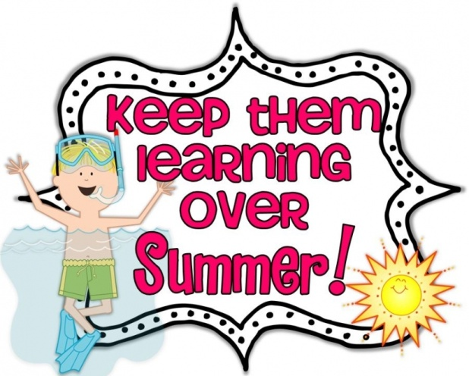
- Help your mother in kitchen and laying down the dining table. Pick your plate after every meal to learn dignity of labor.
PRACTICE TIME:
- Do more practice of hand writing at home.
- Revise all the syllabus done in class till May.
- Do 2 pages once a week of fun with color book.
- Do page 1 to 11 in I.A.B.
- Do page 19 to 27 in K.M.B.
- शब्द अभ्यास पेज न. 1- 4

Also:
- Visit a local attraction in Delhi and library to see a Story and Rhyme books.
- Go to open areas, spaces like a park nearby your home with your parents, avoid to sit at home and watch TV & play video games, as it affects your eyes.
- Take them to a historic site nearby.

Here’s wishing you and your child a very happy summer vacations.

