DAV PUBLIC SCHOOL, EAST OF LONI ROAD,DELHI-93
HOLIDAY HOMEWORK(2020-21)/CLASS– III
TOPIC- STAY CLEAN & STAY HEALTHY

GENERAL INSTRUCTIONS
1. The assignments given are interdisciplinary in nature. There is only one theme for all the subjects in a class, based on which the home assignment is given in different subjects by the respective teachers.
2. The material used for projects/models has to be eco-friendly and try to make best out of the material available easily.
3. The whole assignment has to be of not more than 10 pages or 12 slides (in case of PowerPoint presentation) in total, 2 pages/2 slides for each subject.
4. Students are expected to do the given activities themselves under the guidance of parents (wherever required).
ENGLISH
The pandemic period has taught us the importance of staying clean. Keeping Clean is the key to prevent many diseases. So, during these vacations make keeping clean an inevitable habit with the help of the following activities and enjoy!!!
1. Video Wise To Dictionaries
- Watch the videos on Health and Hygiene.
(Video-1: https://www.youtube.com/watch?v=B7RS-vLZ1yk
(Video-2 : https://www.youtube.com/watch?v=-CIYTf7Oky4)
- Make a list of twenty new words that you listened while watching the videos in a rough notebook and in any word processor/Tux paint (this activity will be assessed in computer as well).
- Take a coloured spiral notebook.
- Arrange those words alphabetically
- Write words with their meanings in spiral notebook. Also you can paste pictures (if possible).
- Make a beautiful attractive cover page. This cover page will be evaluated by art department.
2. Health Is Wealth
- Let’s describe each letter of the word HEALTH using an adjective on an A4 ruled sheet. Take reference from the given example but don’t use this one as your answer.
(Eg. Happy Energetic Active Lifestyle Thankful Hygiene)
- Also using those words make sentences on the back side of the same sheet. .
3. Just a Minute
- Deliver a one minute speech titled as Health talk on any of the following topics-
  - Importance of good health.
  - How to maintain personal hygiene.
- Your video should include very brief including self-introduction of yourself.
- Mail the video at the mail id given below mentioning your name, class and roll number in the subject of the mail. For e.g.: RIYA/IIIA/21
III-A : pooja.singhps4@gmail.com
III-B: ayushig247@gmail.com

MATHEMATICS
During this time, the most essential thing we learnt is cleanliness. Keeping yourself clean can make you healthy. Moreover, for that we all have to keep some precautions in our mind and follow them wholeheartedly. Therefore, hereis your project related to this:
You have to make a Time Chart of June Month in which you have to note down the list of precautions taken by your family members when they go out and come back to home.
- Encircle the date on your calendar when any of your family members go out.
- Remind him/ her to wear a mask, keep sanitizer, washing hands as well as face for 20 seconds with soap, sanitize all the possible things that come in direct contact, use handkerchief while sneezing or to blow nose etc.
- For doctors/nurses/ health workers/ cleaning department workers/ police officers- washing clothes also.
- In addition, in your calendar you have to tick all the precautions they have taken to clean themselves. Here is an example of your Calendar. You can add as many things as you can.
To Do List | 1st June | 2nd June | 3rd June | 4th June | 5th June | 6th June
Mask
Sanitizer
Hand Wash
Cleaning Clothes

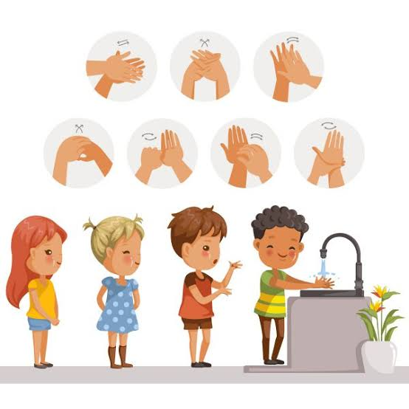
SOCIAL SCIENCE
“ IT IS HEALTH THAT IS REAL WEALTH, NOT PIECES OF GOLD AND SILVER”
- GOOD MANNERS AND GOOD HABITS
Objective: Student will be able to generate awareness towards healthy lifestyle
Good manners and good habits are lifelong assets and they should be practiced until they become habit. Revise the four magical words: PLEASE, SORRY, THANK YOU and EXCUSE ME which we have learned as the part of basics of good manners. Make these four magical words a habit and see the difference. Please refer:
http://www.gomommygo.com/positive_behaviors.html
- HYGIENE
Objective: Self-management skills are developed through personal hygiene and cleanliness.
- Brush your teeth twice a day.
- Trim your nails often.
- Do not waste water and electricity.
- Keep your surroundings and environment clean.
- It is a bad habit to throw things out of the windows, car or balcony.

- Make a video of yourself showing necessary measures to keep body and surroundings hygiene.
- Read chapter 6 and 7, write meanings of difficult words in rough notebook.
- Learn the capitals of all 28 states of India.
- Do practice of states on the political map of India.

EVS
Cleanliness and hygiene play a very important role in everyone’s life. Nowadays, it has become an utmost priority to stay clean & healthy due to Covid-19, so let us do our bit to fight against it.
Be a Corona Warrior andprepare a Self- protection kit containing the following items:
Mask, gloves, hand sanitizer, handwash, napkins
(You can also add other available things which you think can help you in fighting this deadly disease)

हिन्दी
- आप अपने आपको और अपने परिवार को स्वच्छ रखने के लिए क्या क्या प्रयास करते हैं ? इस विषय पर
पाँच वाक्य लिखिए |
- स्वच्छता और अस्वच्छता सेसंबंधित शब्दों की शब्द पिटारी बनाइए |
- जैसे- (स्वच्छता) दाँतों को साफ करना , हाथ धो कर खाना खाना
- (अस्व्च्छता) बासी भोजन , गंदेवस्त्र
- स्वच्छता विषयपर कोई कविता याद कीजिए तथा उसका ऑडियो \ वीडियो बनाइए |

नैतिक- शिक्षा

1. किन्हीं पाँच आर्य महा पुरुषों के जीवन चरित्र को पढ कर उन का संक्षिप्त जीवन परिचय याद करो|
2. कक्षा में कराये गये कार्य को पूरा करो |

