DAV PUBLIC SCHOOL EAST OF LONI ROAD, DELHI
CLASS – IV
SYLLABUS (2019- 20)

ENGLISH
I Cycle Test
My English Reader
Unit-1 Sports
1. Sports
2. A true friend
3. Mix up at birth
4. What’s really important
5. A test of strength
Grammar
1. Noun and its kind (common, proper, collective)
2. Pronoun
3. Gender
4. Preposition
5. Tense( present indefinite, past indefinite)
6. Punctuation
Unseen passage
Writing skills
1. Diary Entry
2. Paragraph writing
Activities
- Paste a picture of your favourite sports person and write six lines about him.
- Pronoun based activity( Identify wrong pronouns from a paragraph)

II- Cycle Test
My English Reader
Unit-2 Travel
1. Travel plans
2. Jungle safari
3. Kanyakumari-Where three seas meet
Grammar
1.Adjective
2. Determiners
3. Tense(present continuous , past continuous)
4. Punctuation
Unseen passage
Writing skills
Lost and found [notice writing]
Activities
- Prepare a travel brochure of your favourite holiday destination.
- Activity on adjectives-(Pick one adjective from the box and describe it.)
III Cycle Test
My English Reader
Unit-3 Wit and Humor
1. The rich lady and the artist
2. The foolish men
3. Clever fox
Grammar
1. Verb
2. Adverbs
3. Tense (Present and past)
4.Punctuation
Unseen Passage
Writing Skills
Formal letter writing
Activities
- Write one humourus act or incident from your daily life.
Final Term
My English Reader
Unit 4: Fantasy
1. Fantasy (Poem)
2.In the land of Lilliput
3. King Thrush bear
4.Let us visit the fantasy land
5. Rizi, the Alien
6. A true friend
7.Jungle Safari
8.The rich lady and the artist
Grammar
1 .Subject and Predicate
2. Conditionals
3.Tense( Present , past, future indefinite, future continuous)
4. Punctuation
5.Adjectives
6.Verbs
Unseen passage
Writing skills
1. Informal letter writing
2. Notice Writing
Activities
1.Describe your experience of going to Rizi’s planet in about one paragraph.
2. Draw your fantasy land and mention the unique things you had imagined there.

SCIENCE
I-Cycle
L-1 My Body
L-2 Plants
Activities-
1. Make a book mark on care of teeth.
2. Collect and bring any one edible root. Observe it and identify its type.
II-Cycle
L-3 Flowers & Fruits
L-4 Plants Around Us
L-5 Birds: Beaks & Claws
Activities-
3. Use dried fallen flowers & leaves to make a greeting card.
4. Make a collage on plants grown in different regions like hills, plains, marshy areas, deserts etc.
5. Make a model of beak and claw of a bird using wool, cotton, feathers etc.
III-Cycle
L-6 Insects
L-7 Food
Activities-
6. Collect the information about any one disease spreading insect along with the pictures. Also mention the name of diseases spread and their prevention.
7. Prepare a balance diet plan plate .
Final Term
L-1 My Body
L-3 Flowers & Fruits
L-6 Insects
L-8 Water Scarcity &Conservation of Water
L-9 Safe Handling & storage of Water
L-10 Water Pollution
Activities-
8. Prepare a slogan on save water to create awareness.
9. Poster on ‘Save water’.

SOCIAL SCIENCE
I-Cycle
Ch-1 Family relationship
Ch-2 Sensitivity towards others
Ch-3 Celebrating our Diversity

Activities
Ch-1 Family- Let us get to know you
1. An activity to complete , _____ All about me ( to fill the information on the given paper)
2. Prepare a family book
Ch-2 Write your name in sign language.
Ch-3 Write the name of five festivals of India and paste the name of festival in its relevant state on the map of India where they are celebrated.
II-Cycle
Ch-4 An ideal home
Ch-5 Bricks and Bridges
Ch-6 Waste management
Awareness about cleanliness
- Make two dustbins for Bio degradable & Non- Biodegradable waste for your class and for the classes on your floor to use (under the cleanliness drive).
- Collect the information on any one method of waste disposal, and arrange the same information on the A4 sheet in the different ways according to your talent in. Art, small paragraph, flow or web charts , tables etc.
- Make a web chart on the stages of brick making process.

III-Cycle
Ch- 7 The works we do
Ch-8 Leisure time
Ch–9 Directions
- Make a collage with the information and picturs of sports persons (any one) who has
- achieved their dream such as
- Milkha singh, Marykom ,E.Sreedharan & write 2 lines on it.
- Understand the directions with the help of sunrise.
- To make a clock showing cardinal directions and intermediatery directions.
Final Cycle
Ch-10 Tours & Travels
Ch-11 Let us travels
Ch-12 let us communicate
Ch-13 India our Motherland
Ch-2 Celebrating our Diversity1
Ch-6 Waste management

Ch-9 Directions
- Draw or bring pictures of different modes of transport, used all over India, classify them in Rural and Urban transportation.
- Write the name of 5 News Papers you get at home and 5 TV news channels.
- Model of Physical features of India using news paper, clay and colour.
Note :-
Ch.2 form 1st cycle .
Ch. 6 form 2nd cycle
Ch 9 from 3rd cycle are included in the final term.

MATHEMATICS
I Cycle Test
1. Numbers upto 9,99,999
2. Addition and Subtraction
3. Multiplication
4. Fun with Patterns
Activities:-
- Place Value Slider: - Make a Place Value Slider by using different colour thick sheets.
- Patterns making:-Make a beautiful for your class Activity Board by following the repetition of a particular pattern.
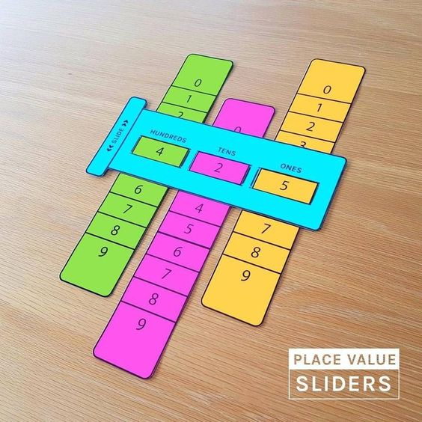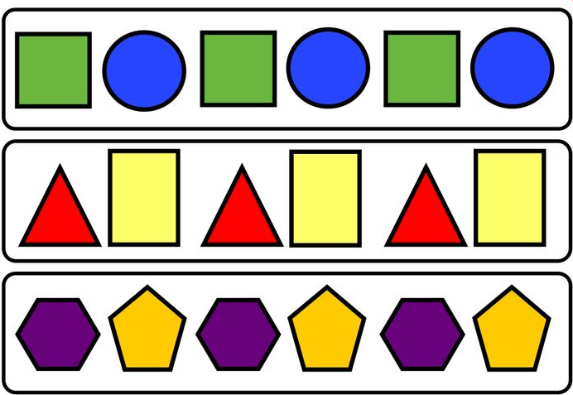
II Cycle Test
5. Division
6. Length
7. Weight 8. Angles
Activities:-
- Write the word ‘MATHEMATICS’ using straight lines and observe the number of right angle, angle more than the right angle and angle less than the right angle in the following table. i.e.
S.No | English Alphabet | No. of Right angle | No. of Obtuse angle | No. of Acute angle
1. | M | 0 | 0 | 3
2. | A
3. | T
4. | H
5. | E
6. | M
7. | A
8. | T
9. | I
10. | C
11. | S

- My Height: - Measure your height in centimeters and paste your picture in your scrap book.

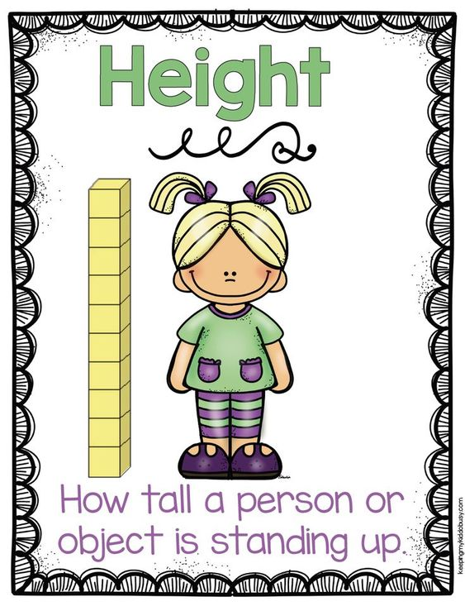
III Cycle Test
9. Capacity
10. Time and Calendar
11. Fractions

Activities:-
- Paste the picture of any five things which can be used to measure capacity.
- Fraction Tree: - Make a fraction tree using same size of strips of different fractional value of a number.

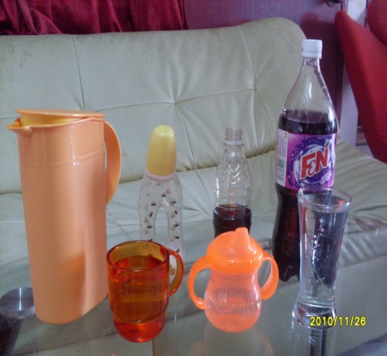
IV Cycle Test
12. Perimeter
13. Area
14. Volume
1st -------- Multiplication
2nd -------- Division
3rd --------- Fractions
Activities:-
- Find my boundary: - The students make a foldable and an array of their choice length and breadth using grid paper. The students glued their array on the outside of a foldable. On the inside, the students wrote the perimeter of their shape.
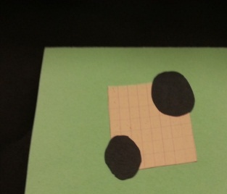
- Measure the length, breadth and height, in centimeters of an almirah and calculate its Volume. Also shade the part which shows its length, breadth and height on different shapes.

GK
CONTENT
Pages Pages Pages Pages
Lang & Literature 1-3 4-6 7-9 10-13
Environment Around 14-16 17-19 20-23 24-26
World Around 27-29 30-32 33-35 36-38
Art & Culture 39-40 41-42 43-44 45-46
Math & Magic 47-49 50-52 53-55 56-57
Sports & Games 58-59 60-61 62-63 64

COMPUTER
I-CYCLE
Ch-1 Computer – A Machine Ch-2 More on Tux Paint Ch-3 Exploring Tux Paint Activity • Create a story on the topic ‘Slow & Steady wins the Race’ • Draw a picture in Tux Paint and use mirror and flip options under magic tool. What happens to your drawing?
II-CYCLE
Ch-4 LOGO-I Ch-5 LOGO-II Activity • Creation of different alphabets & numbers using LOGO graphics • Draw the different Geometrical designs in LOGO
Final Term
Ch-6 Writer Getting Started Ch-7 Editing in Writer 6 Ch-8 Internet as A Pool of Information Activity • Create a birthday invitation card on Writer. • Explore different terms related to Internet.
ART & CRAFT-
Note-Art books are divided n into Three Cycle Test. The detail of course material in each Cycle Test is mentioned below for further follow up in the class as study material program me .The same will be treated as guideline for the students of the class to be completed well in time. For more clarity subject concern teacher will intimate you time to time.
First Cycle Test
Step by Step Book
1. Rack tangle-Pencil Shading
2. Cone & Circle- Pencil Shading
3. Oil Container- Pencil Shading
4. Jug , Pot , Book & Elmira-Jug & Mug
5. Tea Set, Glasses & Mug-Flower Pot
6 . Flowers-Fruits Basket
Second Cycle Test
Step by Step Book
1. Vegetables Composition
2. Animal Composition
3 Birds Composition
4. Faces with different angles
5.Garden - Different Faces
6. Vegetables Seller
Third Cycle Test
Step by Step Book
1. Balloon Seller
2...Ice Cream Seller
3. Landscape-Seascape
4. Alphabets-Method
5. Poster-Do Not Cut Tree
6. Poster-Save Water
हिन्दी
प्रथम चक्र
भाषा माधुरी
१. फैलती चप्पलें
२. उलटा-पुलटा
३. अनोखा ढंग
५. सेर को सवा सेर
भाषा अभ्यास:- पृष्ठ संख्या 1 से 10
व्याकरण:- संज्ञा, भाषा विचार, क्रिया, वचन बदलो, लिंग बदलो, विलोम शब्द,अनुच्छेद,चित्र वर्णन, संयुक्त व्यंजनों से बनने वाले शब्द, वाक्यांश के लिए एक शब्द,बिंदु और चंद्र्बिन्दु का प्रयोग, पर्यायवाची शब्द |
गतिविधि:- पाठ्यक्रम के अनुरूप गतिविधियाँ करवाईं जाएँगी।
द्वितीय चक्र:-
४. मित्रता
६. पहली बारिश
७. दादी का रेडियो
९. नानी की नाव चली
८. किस्से-कहावतों की दुनिया
भाषा अभ्यास:- पृष्ठ संख्या 14 से 29
व्याकरण:- संज्ञा, क्रिया, वचन बदलो, लिंग बदलो, विलोम शब्द,अनुच्छेद,चित्र वर्णन, मुहावरे, सर्वनाम, युग्म शब्द, समश्रुत भिन्नार्थक शब्द, विशेषण , विशेष्य,बिंदु और चंद्र्बिन्दु का प्रयोग, पत्र|
गतिविधि:- पाठ्यक्रम के अनुरूप गतिविधियाँ करवाईं जाएँगी।
तृतीय चक्र:-
१०.एक बौना और लकड़हारा
११. मौसम
१८.खत पहुँचे सक्को को
१२. आँख -मिचौनी
१३. चतुर चित्रकार
भाषा अभ्यास:- पृष्ठ संख्या 30 से41
व्याकरण:- संज्ञा, , वचन बदलो, लिंग बदलो, विलोम शब्द,अनुच्छेद ,काल, मुहावरे, युग्म शब्द ,सर्वनाम, विशेषण विशेष्य पत्र, ,बिंदु और चंद्र्बिन्दु का प्रयोग |
गतिविधि:- पाठ्यक्रम के अनुरूप गतिविधियाँ करवाईं जाएँगी।
चतुर्थ चक्र:-
२. उलटा-पुलटा
९. नानी की नाव चली
१३. चतुर चित्रकार
१४. एक थी स्वाति
१५.होली के रंग हज़ार
१६. ऐसे भी बच्चे
१७. कोयल
भाषा अभ्यास:- पृष्ठ संख्या 6 से8,38-54
व्याकरण:- संज्ञा, सर्वनाम, उपसर्ग, प्रत्यय, लिंग बदलो, विलोम शब्द,अनुच्छेद ,काल, विशेषण , पत्र, विराम चिह्न, अनेकार्थी शब्द,बिंदु और चंद्र्बिन्दु का प्रयोग, अपठित गद्यांश, पठित काव्यांश |
गतिविधि:- पाठ्यक्रम के अनुरूप गतिविधियाँ करवाईं जाएँगी।

नैतिक - शिक्षा
१ - चक्रीय परीक्षा - पाठ १ से ७ तक , मन्त्रोंच्चारण , कहानी ।
२- चक्रीय परीक्षा - पाठ ८ से १४ तक , मन्त्रोंच्चारण , कहानी ।
३- चक्रीय परीक्षा - पाठ १५ से २१ तक मन्त्रोंच्चारण , कहानी ।

