DAV PUBLIC SCHOOL EAST OF LONI ROAD, DELHI
CLASS – III
SYLLABUS (2019-20)

ENGLISH
I-Cycle Test
My English Reader
Unit 1: Animal World
1. Poem – I speak , I say I talk
2. Dolphins
3. Dog
4. At the Zoo
5. The Canary
6. The Ostrich and the Hedgehog
Grammar
1. Noun (kinds of Noun- Common Noun, Proper Noun)
2. Pronoun
3. How many? (Numbers)
4. Punctuation (Full stop, Comma )
Unseen passage for comprehension
Writing skill:- Paragraph writing on ‘My pet’ with inputs
Activities :1. Individual Poem Recitation - I speak , I talk
2. Spellathon - Words from the Prose ‘ The Canary’ and ‘At the zoo’
II Cycle Test
My English Reader
1. Arjuna’s friends of the forest
2. Amazing Animals and Birds
Unit 2. Nature cares
3. The God of River
4. Poem – Trees are the Kindest things I know
5. Minu and Dino
6. Trees
Grammar
1. Adjective
2. Verbs
3. Tense (Present Tense)
4. Punctuation (Full stop, Comma & question mark)
5. Unseen passage for comprehension
Writing Skills
Guided picture composition on ‘Save Trees’.
Activities:
1.Prepare a poster on ‘Water Pollution’ . Mention some ways to reduce it.
2. Individual poem recitation –Trees are the kindest things I know.
III CYCLE TEST
My English Reader
1. Chipko Movement
2. Harmful effects of Polybags
Unit 3. Regard for values
3. Nina is the Winner
4. Poem - Two little Kittens
5. Krishna and Sudama
Grammar
1. Preposition
2. Articles
3. Tense (Past Tense)
6. Punctuation ( Capital & small letters , Exclamation mark, full stop, comma)
7. Unseen Passage
Writing Skills
Story Writing using aid box
Activities
1.Make a paper bag and mention harmful effects of using poly bags.
2. Prepare a ‘ Get well soon ‘ card for your friend who met with an accident recently.
FINAL TERM
My English Reader
1. The Birthday Kitten
2. The Plate of Gold
3. Man learns to fly
4. Poem - The Key
5. Michael goes climbing
6. The Magic room
7. Florence Nightingale
8. India’s young heroes
9.The canary
10.Krishna and Sudama
Grammar
1. Subject and predicate
2. Unseen Passage
3. Tense (Future)
4. Punctuation (inverted commas & Apostrophe)
5.Adjective
6.Verbs
Unseen passage for comprehension.
Writing Skills:
1. Frame a story by using Word Bank
2. Leave application
Activities:
1.Prepare a wish card for genie.
2. Match flash cards of famous personalities with their achievements.
MATHEMATICS
I Cycle Test
1. Numbers upto 9,999
2. Addition
3. Subtraction
Activities:-
- Perry, the place value robot; in this activity The graphic organizer allows students to show a number in word form; base ten form, expanded form, and number form.
- Addition of playing cards; in this activity students will paste at least two pairs of 4 different cards (2-9) in his/her notebook and then add those numbers formed and subtract smaller number from bigger number. Repeat this activity 5 times.

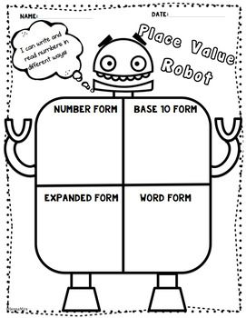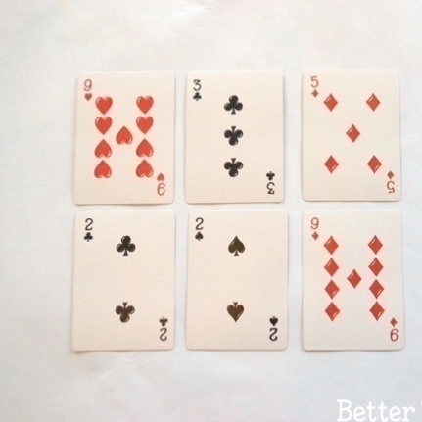

II Cycle Test
4. Multiplication
5. Division
6. Money
Activities:-
- Multiplicative Peacock: in this activity student will make a face of a peacock and on its feathers write different ways of multiplication i.e. Array Multiplication, repeated Addition, Equal grouping, and number line.
- Units of Length: - in this activity student will list out some customary and metric units of length measurement. And draw/paste the pictures of any one item which can be measure using that unit.

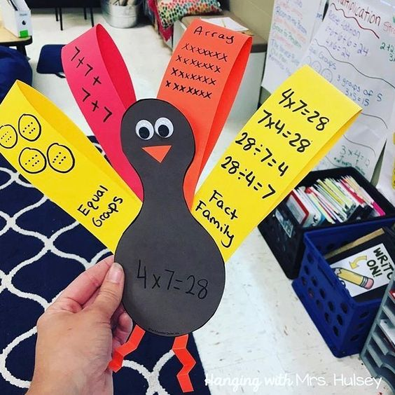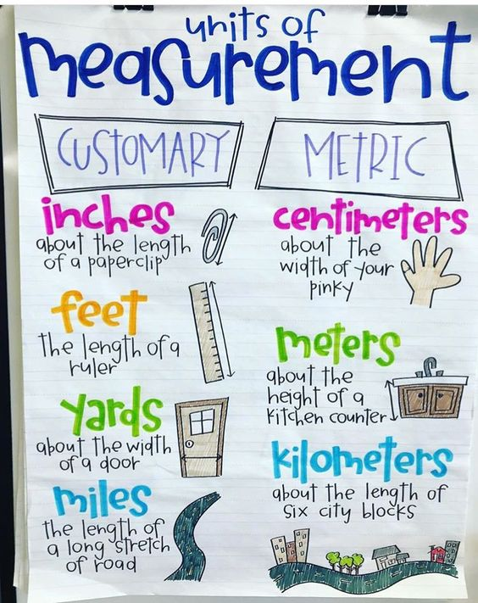
III Cycle Test
7. Length
8. Weight
9. Capacity
Activities:-
- Fraction Flower: - Make any five fraction flower in your notebook, in which any fractional number will be shown on a colour paper plate.
- I can measure as:-Make a list of objects whose weight is measured in grams/ kilograms and capacity in liters/milliliters. Paste the pictures of those objects in separate sheets for weight and capacity respectively.

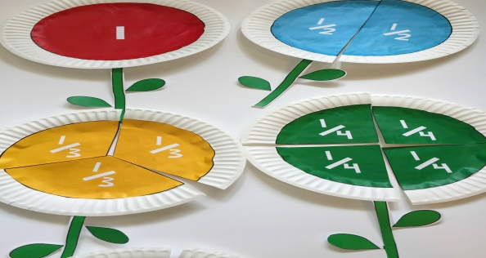

IV Cycle Test
10. Fraction
11. Day, Date and Time
12. Geometry
1st --------Numbers Upto 9,999
2nd -------- (i) Multiplication
(ii) Division
3rd --------- Fraction
Activities:-
- 3D building: -Build any two 3D shapes using colour sheets.
- Telling Time Clock: -make a clock and show time to the 5 minute mark with Quarter till and Half past lines.

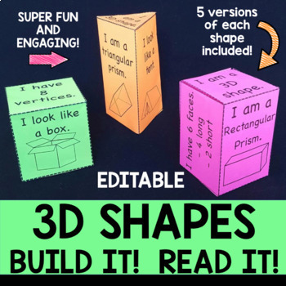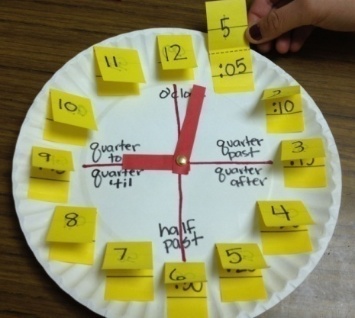

EVS
I-Cycle
L-1 My body
L-2 Plants around us
Activities:-
1.Test your sense organs.
a. By identifying different taste buds of tongue as sweet, sour, salty & bitter.
b. By identifying different sounds.
c. By touching different objects.
2. Make a poster on ’Save Tees’
II-Cycle
L-3 Leaf.
L-4 Importance of plants.
L-5 Animals.
Activities:
1. Observe the world of leaves closely and make a greeting card out of their impressions.
2. Group activity on collage making on different things we get from plants on A3 size sheet using pictures and real specimens.
3. Draw and colour your favourite animal and speak on it.
III – Cycle
L-6 Feeding habits of animal
L-7 Bird and their nests.
Activities:
1. Paste pictures of 3 different animals in notebook and then classify them on the basis of food, feeding habit and type of teeth.
2. Make a model of nest using fallen leaves, cotton, sticks etc.
Final Term
L-1 My Body
L-3 Leaf
L-7 Bird and their nests
L-8 Food
L-9 Cooking and eating habits
L-10 Water
Activities:
1. Paste pictures on A3 sheet on different food items obtained from (a) Wheat (b) Rice.
2. Preparing a Placard of cooking methods of any one food itemof their own choice.
3. Write a slogan on ‘ Save Water’.
SOCIAL SCIENCE
I CYCLE TEST
Ch 1 The Family
Ch 2 Family Similarities
Ch 3 Our Food
ACTIVITIES
- Students will draw a Family tree by showing all the family members
- Paste the picture of Joint and Nuclear Family.
- Students will paste the pictures of Indian spices and dry fruits with their English Name.
- Map Skills.
II CYCLE TEST
Ch 4 Our dresses
Ch 5 The Early Man
Ch 6 Learning about works
ACTIVITIES
1. Students will paste different fabrics and write their names.
2. Name draw and paste the things which are used in our homes to make our life comfortable.
3. Write the names of any three books and their authors which the students will read in their library period.
4 Map Skills.
III CYCLE TEST
Ch 7 If you believe you can, you will
Ch 8 Let us enjoy
Ch 9 Our Homes
Ch 10 Beautiful homes
ACTIVITIES
1. Watch the Movie ‘Mein bhi hoon Kalam’
2.Prepare any one board game you play in your leisure time.
3. Collect information on metro man and paste his picture in your note book
4 Map Skills.
IV CYCLE TEST
Ch 11 Directions
Ch12 Conquering distances
Ch 13 Closing distances
Ch 14 I am proud to be an Indian

ACTIVITIES
1. Listing and pasting pictures of the things that you use to keep your house neat and clean.
2. Means of transport: Categories them under air, water and land. Prepare a collage on different means of transport.
3. Draw the pictures showing development of wheel.
4. Making of a pictorial collage showing different means of communication.
5 Map Skills.
6 Chapter 2,5,6 will also come in final cycle test
COMPUTER
I CYCLE TEST
Ch-1 Getting started Ch-2 Fundamentals of Computers.
Activity –
Compare yourself with a Computer 1.Write any 3 tasks in which you think computer is better than you. 2.Write 3 tasks in which you feel you are better than computers.
II CYCLE TEST
Ch- 3 Keyboard , Ch-4 Touch typing : Play with Text Editor Ch- 5 Know the Keyboard
Activity -Using colour paper cut the various shapes and paste them in the your notebook. Remember to cut and paste only those shapes which are part of shapes tool bars.
FINAL CYCLE TEST
Ch- 6 Using the Icons, Ch- 7 Tux Paint: Lets paint the World, Ch-8 Use safe: Precautions while using Computers
Activity
- Open the Tux Paint and observe the tool bar carefully. List and draw all tools in your notebook

A
ART & CRAFT
Note-Art books are divided n into Three Cycles Test. The detail of course material in each Cycle Test is mentioned below for further follow up in the class as study material programme .The same will be treated as guideline for the students of the class to be completed well in time. For more clarity subject concern teacher will intimate you time to time.
Class-III
First Cycle Test
Step by Step Book
1. Over lapping Shapes-Three Shape
2. Over lapping Shapes-Four Shape
3. Clock. Cap & Ball Composition
4. Tin Boxes-Composition
5 Jug, Plate, Glass & Mug Composition
6. Fruits in a Plate
Second Cycle Test
Step by Step Book
1. Fruits Basket
2. Flower Pot
3. Boy Figure
4. Girl
5. Man
6. Woman
Third Cycle Test
Step by Step Book
1. Boy
2. Girl
3. Boy
4. Different Costume Design
5. Birds
6. Zoo Scene
G.K
Content Cycle- 1 Cycle- 2 Cycle- 3 Cycle-4
Language &Literature Page 1-3 4-5 6-7 8-9
Environment Around 10-12 13-14 16-18 19-23
World Around 24-26 27-30 31-34 35-38
Art &Culture 39-40 41-42 43-44 45-46
Math magic 47-48 49-50 51-52 53-54
Sports &Games 55-56 57-58 59-60 60

हिंदी
प्रथम चक्र :-
भाषा माधुरी- १. भोलू भुलक्कड़
२. चतुर कौवा
३. हाथी और चिड़िया
४. चींटी ने पाठ पढ़ाया
भाषा अभ्यास- पृष्ठ संख्या 1 से 7
व्याकरण- संज्ञा, क्रिया,वचन बदलो, विलोम शब्द, चित्र वर्णन, शब्द
सीढ़ी, ड़ एवं ढ़ से बनने वाले शब्द, बिंदु और चंद्रबिंदु का प्रयोग।
गतिविधि- गतिविधियाँ पाठ्यक्रम के अनुसार करवाई जाएँगी।

द्वितीय चक्र:-
भाषा माधुरी- ५ बहादुर दोस्त
६ घमंडी मक्खी

७ दादाजी
८ अगर पेड़ भी चलते होते
भाषा अभ्यास- पृष्ठ संख्या 8 से 19
व्याकरण- लिंग बदलो, वचन बदलो, विलोम शब्द, अनुच्छेद, चित्र वर्णन, शब्द
सीढ़ी,क्रिया, ड़ एवं ढ़ से बनने वाले शब्द,बिंदु और चंद्रबिंदु का प्रयोग।
गतिविधि- गतिविधियाँ पाठ्यक्रम के अनुसार करवाई जाएँगी।
तीसरा चक्र :-
भाषा माधुरी- ९. गीत का कमाल
१०. बूझो तो जाने
११. चूँ-चूँ की टोपी
१२. सुबह
भाषा अभ्यास- पृष्ठ संख्या 20 से 27
व्याकरण- विशेषण,बिंदु और चंद्रबिंदु का प्रयोग, विराम चिह्न, पत्र, अनुच्छेद, अनेक शब्दों के लिए एक शब्द, लिंग बदलो, वचन बदलो, विलोम शब्द,नुक्ता का प्रयोग |
गतिविधि- गतिविधियाँ पाठ्यक्रम के अनुसार करवाई जाएँगी।
वार्षिक चक्र:-
भाषा माधुरी- ३. हाथी और चिड़िया
५ बहादुर दोस्त
१०. बूझो तो जाने
१३ ऐसे थे लाल बहादुर शास्त्री
१४ सबसे बड़ा मूर्ख
१५ बुआ का पत्र
१६ सवालीराम
भाषा अभ्यास- पृष्ठ संख्या 28 से 36
व्याकरण- संज्ञा, क्रिया, विशेषण, वचन बदलो, विलोम शब्द, लिंग बदलो,
अनुच्छेद,चित्र वर्णन, पत्र, मुहावरे, बिंदु और चंद्रबिंदु का प्रयोग।
गतिविधि- गतिविधियाँ पाठ्यक्रम के अनुसार करवाई जाएँगी।

नैतिक - शिक्षा
१- चक्रीय परीक्षा - पाठ १ से ६ तक , मन्त्रोंच्चारणादि ।
२- चक्रीय परीक्षा - पाठ ७ से १२ तक , मन्त्रोंच्चारणादि ।
३- फ़ाइनल चक्रीय परीक्षा , पाठ १३ से १७ तक , मन्त्रोंच्चारणादि ।

