C.M.D.A.V.Sen. Sec. Public School, Dabwali
Monthly Syllabus Session -2021-22
Std. U.K.G Month:-December
Subject:- English
English( R) Pg. no.34 to 42
English (Int.)Pg. no.45 to 59
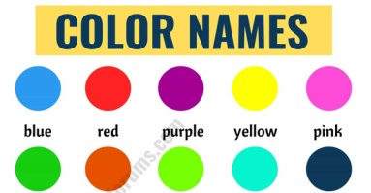
Colour’s name in note book.
Activity:- Hug and Whisper
Rhymes:- My Family Pg.no 31
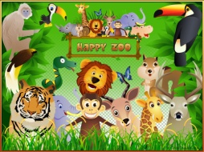
Going to the zoo Pg.no.8
Subject:- Hindi
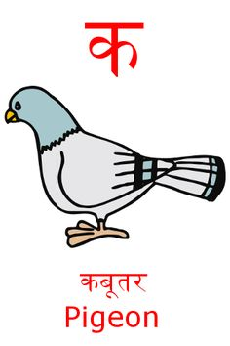
Hindi( M) Pg. no.37 to 56
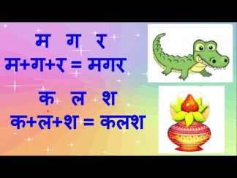
Hindi (A)Pg. no.23 to 39
Write the name of pictures.
Activity:- Jump into a circle.
Rhymes:- Page no.13

Subject:- Maths
Pg. no.45 to 60
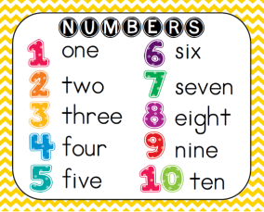
Counting 101 to 200
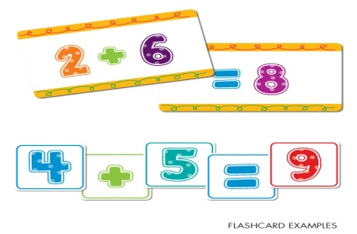
Number names 1 to 10
Activity:- Add the objects.

Subject:- E.V.S
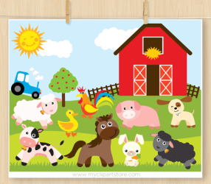
Topic:- Babies of animals
Activity:- Introduce babies of a nimals with Rhyme
Topic:- Our Helpers
Activity:-Done by pictures.
Drawing and craft:-Drawing with numbers and Pg no. 16 to 20
Physical Edu. Frog Race
Conv.Q1 What is your name?
My name is ……………
Q2 How old are you?
I am ………. Years old.
Q3 Where do you live?
I live in/at ………………..
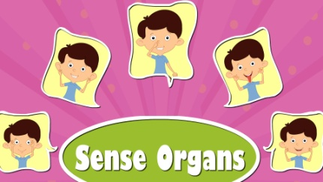
Q4 Name of five sense organs.
Eyes,Ears,Nose,Tongue and Skin.

